1NC 2
1NC 4
1NC 5
1NC 6
1NC 7
Diagram of Sexuation 8
Framework: Sexual Difference Can’t Be Symbolized 9
Framework: Sexual Difference Can’t Be Symbolized 10
Framework: Sexual Difference Can’t Be Symbolized 11
Framework: Fem. and Masc. Positions Asymmetrical 12
Framework: Fem. and Masc. Positions Asymmetrical 13
Framework: Fem. and Masc. Positions Asymmetrical 14
Framework: Language Castrates 15
Link: Choice 16
Link: Capitalism 17
Link: Liberal Society 18
Link: Happiness 19
Link: Search for Good 20
Link: Search for Good 21
Link: Search for Good 22
Link: Suspension of Master 23
Link: Language 24
Link: Rights 25
Link: Rights 26
Link: Rights 27
Link: The Law 28
Link: Naturalization of Law 29
Link: Transgressing the Law 30
Link: Enforcement of the Law 31
Link: Property 32
Impact: Logical Order Can’t Capture Feminine Jouissance 33
Impact: Feminine Jouissance 34
Impact: Feminine Jouissance 35
Impact: Masc. & Fem. Jouissance 36
Impact: Phallic Law 37
Impact: Phallic Law 38
Alternative: Status Quo 39
Alternative: Feminine Jouissance 40
Alternative: Psychoanalysis 41
Alternative: Psychoanalysis 42
Alternative: Psychoanalysis 43
Alternative: Discourse of Love 44
Alternative: Overidentification 45
Alternative: Overidentification 46
Alternative: Overidentification 47
Alternative: Overidentification 48
AT: “Psychoanalysis Irrelevant to the Law” 49
AT “Lacan’s Formulae are Illogical” 50
AT: “Lacan Not Scientific” 51
AT: “Lacan Not Scientific” 52
AT: “Lacan Not Scientific” 53
AT “Sexual Difference Can be Avoided” 54
AT “Lacan is Bioessentialistic” 55
AT: Feminism 56
AT: Feminism 57
AT: Feminism 58
AT: Feminism 59
AT: “Together the Sexes Form a Whole” 60
AT Intersubjectivity 61
AT: CLS 62
AT Capitalism is Psychotic (D&G) 63
AT Queer Theory 64
AT: “Lacan is Incomprehensible” 65
FYI—Formulae 66
FYI—Formulae 67
FYI—Diagram 68
Drug Use Impact Module 69
Drug Use Impact Module 70
Drug Use Impact Module 71
Drug Use Impact Module 72
Drug Use Impact Module 73
Drug Use Impact Module 74
AT Drug Use Impact Module 75
Aff Answers: Rights Necessary 76
Aff Answers: Rights Necessary 77
Aff Answers: Feminism 78
Aff Answers: Masc. Jouissance Necessary 79
Aff Answers: Law Necessary 80
Aff Answers: Law Necessary 81
Aff Answers: Must Choose a Big Other 82
Aff Answers: Lack Necessary 83
Aff Answers: Alt. Non-Unique 84
Aff Answers: Lacan Incomprehensible 85

1NC

Lacan’s improper use of predicate logic suggests that the event of castration is as fundamental for our relationship to the symbolic order as are the rules of logic and dictate the structural positions available to speaking beings without reference to biology. Hence, there can be no sexual relation, because it is impossible to mediate between the two possible outcomes of the event of castration. Moreover, because the system of logical rules is phallic, the logical order fails to capture the essence of the feminine position, which is defined as a supplementary jouissance outside of the logical order. However, because there is no “outside” of the law, woman only appears within the law as doubled.
Freiberger 1998.
[Erich, Ph.D., Boston College, “The Cross Dressing of Logic,” Society for Phenomenology and Existential Philosophy, Georgetown University, October 11, 1996, p. 3//jdg-wfi]
So why is Lacan using this notation if it has no proper meaning within the predicate calculus? On the most general level, what he seems to be trying to suggest is that the way our relation to the symbolic order is assumed in the event of castration is something so fundamental for our understanding of sexual difference, that it is on par with the basic notation and rules of deductive logic. So, just as the rules of logic can yield certain results without reference to the particular meanings to which they apply, so too, the structural positions available to speaking beings can be seen as the result of the determinate rules governing sexual difference without reference to biology. On this view the castration complex is a kind of roll of the dice which functions according to rules which are as determinative of sexual identity as the rules of logic are determinative of truth and falsehood. Thus Lacan’s account provides a way of understanding how sexual difference turns not around biology, but rather around the decisive way in which one is subjected to the economy of imaginary identification. This means there can be no genuine sexual relation, Lacan insists, because one can no more mediate between these two possibilities than one can find a middle ground between the binary oppositions of the true and the false in formal logic.
The crux of the problem is Lacan’s claim that this system of logical rules is decidedly phallic, for this permits him to demonstrate that by favoring the masculine, the logical/phallic order fails to capture the essence of the feminine position, which the phallic order can only designate as a “supplementary” jouissance which falls outside it. But as there is no “outside” of the law, woman can only appear within it as doubled. Thus, the diagram below the formulae presents woman as having a dual relation to both the phallus (Φ) and to the signifier of the lack in the Other, S(Ø). What this means is that this peculiar, supplementary, and feminine jouissance is nothing more than a relation to the lack in the law, implying that woman somehow perceives the Other as barred or lacking in a way that man does not.

1NC

Lacan’s formula that reads “there is not one that is not subject to the phallic function” indicates both that there is a “not one” that is exempt from the phallic law and that there is no feminine experience outside the law. Feminine jouissance is both wholly inside and wholly outside the phallic law, and hence must be a jouissance of lack.
Freiberger 1998.
[Erich, Ph.D., Boston College, “The Cross Dressing of Logic,” Society for Phenomenology and Existential Philosophy, Georgetown University, October 11, 1996, p. 5-7//jdg-wfi]
To portray how Lacan’s formulae of sexuation exhibit such an antinomy, let us examine each of Lacan’s formulae in turn. The two formulae on the left signify male desire, and the two on the right represent his attempt to symbolize female desire. The first formula, ∃x(-Φx), says that “there is at least one who is not subject to the phallic function.” We can think of this one who is not subject to the phallic function as the father of primal horde in Totem and Tabu. It is the father’s possession of all the women which marks all the sons as subject to the threat of castration if they try to enjoy the women for themselves. This uncastrated Father who is not subject to the phallic law is the limit case which defines all the rest as subject to the paternal law. Accordingly, the second formulae,∀x Φx, says, “all are subject to the phallic function” which, as we have just seen, means that all male speaking beings are wholly subject to the bar of castration wielded by the paternal law described in the first formula. On the right side, on the top (e.g., #3, in diagram A), we find a formula that is quite strange, (-∃x)(-Φx), which reads: “there is not one that is not subject to the phallic function.” The symmetry of the diagram (which shows the two male formulae on the left, where the top one defines the one below it) creates the expectation that the same relation holds on the right hand side of the diagram, but this is not the case, for as we shall soon see what is at issue in Lacan’s account is a complete lack of complementarity between these two kinds of desire. If Lacan’s table were in standard logical notation the second and third formulae would mean the same thing. In other words, “there is not one that is not subject to the phallic function” would mean the same as “all are subject to the phallic function,” for as everyone knows, a double negation constitutes an affirmation. But given Lacan’s idiosyncratic restriction of the quantifier, which separates the negation of the quantifier from negation of the function, one cannot transform the double negation of “there is not one that is not subject to the phallic function” into the positive affirmation that “all are subject to the phallic function.” On Lacan’s peculiar distortion of the predicate calculus, there is no logical commensurability or complementarity between the masculine and the feminine sides of the diagram. As a result the logical clarity and exclusivity of the masculine side is contrasted with the logically equivocal and undecidable character of Lacan’s formula for feminine jouissance: “there is not one which is not subject to the phallic function,” (-∃x)(-Φx). As one can easily see, this formula can be read in two opposing senses. On the one hand this formula claims that there is a feminine experience outside the law, for the way the negation remains bound to the quantifier renders the privative “not one” as something positive, indicating the existence of a “not one” which is exempt from the law. And yet on the other hand, the formula can also be read as claiming that there is no feminine experience outside the law, because there is not one individual that is exempt from the law. This ambiguity amounts to an antinomy, which states that feminine jouissance is at once wholly inside and wholly outside the phallic order. Now what I propose is that the only way to reconcile these contradictory claims, without lapsing into metaphysics, is to read feminine jouissance as a jouissance of lack, which is unrepresentable as such within the phallic order. Thus, when Lacan writes that there is “not one that is not subject to the phallic function” he means to indicate that feminine jouissance is a jouissance of the lack in the phallic law, and not some otherworldly enjoyment of an imaginary feminine reality beyond the phallic order. The point is that this other jouissance does not fall into neat logical categories because it is nothing that can be positively represented within the phallic order. As a result, it is not necessary that every woman experience it; rather, it is an experience to which women are contingently open. This is why Lacan cancels the definite article, and says that “the woman does not exist,” for feminine jouissance is a contingent non-universalizable experience that cannot be predicated of all women. Some experience it, others do not. This is what he is trying to indicate with the fourth formula, (- ∀x) Φx, “not all are subject to the phallic function.” What this formula indicates is woman’s contingent openness to the jouissance of lack described in the preceding formula.

1NC

Submission to a legal system of rights is submission to the function of castration. For this reason, rights are always insufficient, and we must always seek to create new rights perpetually. However, because rights serve the function of the objet a, this search is in vain.
Salecl 1995.
[Renata, philosopher and sociologist, working as a researcher at the Institute of Criminology, Faculty of Law, University of Ljubljana, “Law and the Postmodern Mind: Rights in the Psychoanalytic and Feminist Perspective,” Cardozo Law Review, 16 Cardozo L. Rev. 1121, ln//jdg-wfi]
The introduction of rights is nothing other than a substitute for the fundamental prohibition to which the individual is submitted upon becoming a social subject. As such, rights serve the same function as the Lacanian notion objet a, the object cause of desire. The objet a is the substitute the subject gets when it is subjected to castration upon entering the realm of symbolic mediation. At the same time, however, the objet a is also the element that renders all other potential substitutes insufficient. For example, when the child is weaned from the breast and loses its primal object of desire, every other object will be seen as a substitute, as something to fill out this place of the primary lost object. Desire will therefore range from one object to another but will always remain unsatisfied, it will always be a "desire for something else" insofar as these new objects are seen as substitutes for the first object. n25 Thus, on the one hand, the objet a fills the lack, the split that traverses the [*1134] subject after castration, but, on the other hand, the objet a prevents any object from really filling this lack. The same goes for rights: although we get them as a substitute for the fundamental prohibition necessary to live in a society, rights actually prevent any substitute from filling the lack which was introduced by the prohibition. Although we have rights, a right that would express the notion of rights itself does not exist. All we can do, in this regard, is to invent new rights perpetually, searching in vain for a right that would affirm us as nonsplit subjects.

1NC

Attempts to universalize human rights are the work of the dominant “male” logic of the formulae of sexuation—in order for nobody to remain without rights, nobody may possess them universally.
Salecl 1995.
[Renata, philosopher and sociologist, working as a researcher at the Institute of Criminology, Faculty of Law, University of Ljubljana, “Law and the Postmodern Mind: Rights in the Psychoanalytic and Feminist Perspective,” Cardozo Law Review, 16 Cardozo L. Rev. 1121, ln//jdg-wfi]
By analyzing the question of the universality and the particularity of human rights with the help of Lacan's formulas of sexuation, n26 we can see how it is possible to articulate the problems of sexual difference and human rights in another way that feminist legal theory does. Through his formulas of sexuation, Lacan argues that man and woman are defined (and split) separately with [*1135] respect to the "phallic function." Lacan understands the phallic function as symbolic castration, as something that happens to a human being when he or she enters language.
Man is completely subordinated to symbolic castration and thus wholly determined by the phallic function. Man's logic is a logic of universality: the whole of a man falls under the phallic function, i.e., man is altogether determined by symbolic castration, but at the same time the position of man implies that there is one man (the Freudian "primordial father") who is an exception and is not subordinated to symbolic castration. This "primordial father," as is well known from Freud's myth, is the possessor of all women, the father who is not subordinated to the law and to whom the threat of castration does not apply. The woman's logic of the formulas of sexuation also has two parts: the first formula says that not all of a woman falls under the phallic function, and the second formula says that every woman is at least in part determined by the phallic function. For women, however, the phallic function does not govern completely. Woman, Lacan says, is in respect to the symbolic order not whole, as she is not totally bounded and determined by the phallic function. But Lacan argues that although not all of a woman is defined by the phallic function, she is nevertheless situated within the symbolic order.
When Lacan says that Woman does not exist, he means that women cannot be adequately defined through language: women have something (the presumed woman's jouissance) that escapes the symbolic order. Bruce Fink, in describing the formulas of sexuation, argues that women have more "direct" access to the Real, to that which is "unsymbolizable," around which the symbolic order is structured. n27 The Lacanian feminine logic thus presents what is particular, what is symbolized, but what also escapes symbolization.
If the idea of human rights is analyzed with the help of Lacan's formulas of sexuation, two logics can be found to be at work in it. According to the first, the currently dominant "male" logic, all people have rights, with the exception of those who are excluded from this universality (for example, women, children, foreigners, etc.). In contrast, according to the second, the "feminine" logic, there is no one who does not have rights, i.e., everybody taken individually possesses rights, but precisely because of this we cannot say that people as such have rights. This feminine logic could be [*1136] called a postmodern logic of rights. According to this model it is not the case that human beings as such have rights, but that none remain without rights. Rights as such cannot be universalized, because universalization always needs an exception: there has to be someone who does not have rights for the universal notion of rights to exist. A postmodern approach to rights would be based on the claim that no one should remain without rights, which also means that no one can universally possess them. Understanding human rights according to the Lacanian formulas of sexuation enables us to articulate a discourse of human rights that does not conceal social antagonisms, while still retaining its critical function.

1NC

Individuals in the masculine sexual position are barred subjects completely defined by their subjection to the phallic law, and subsequently are unable to recognize the limits of the phallic order or the lack it creates. Individuals in the feminine position are defined both by their relation to the phallic law and their exclusion from it. Hence, feminine jouissance is an acceptance of the limitation of being split by the law. Psychoanalysis seeks to lead the analysand to an acceptance of castration. Accepting the lack inherent in the status quo through the psychoanalytic process allows the subject to enjoy his or her lack and to arrive at the place of feminine jouissance.
Freiberger 1998.
[Erich, Ph.D., Boston College, “The Cross Dressing of Logic,” Society for Phenomenology and Existential Philosophy, Georgetown University, October 11, 1996, p. 8-9//jdg-wfi]
In the Schema below the formulae of sexuation, we see that men are portrayed as barred subjects that are completely defined by their subjection to the phallic function. This means that they only desire in one way, by projecting a fantasy, or an objet petit a, onto the object of their desire, which is usually incarnated by a woman. Thus, they have a unitary relation to the phallic order inasmuch as their desire is completely defined by it. The result is that male desire altogether fails to recognize woman’s jouissance.
Women in contrast, have a dual relation to the phallic order. To the extent that women are in the phallic order, they can desire the way men do by projecting their objet petit a. Thus, they can both desire their own objet a, and they can strive to incarnate the objet a for a man. But beyond participating in the phallic order as either subjects or objects of phallic desire, woman may also have a relation to the signifier of the lack in the Ot her, S(Ø). What this means is that to the extent that woman is not altogether subject to the phallic function of castration, she may have a contingent opening to a jouissance of the real lack which the law imposes on the subject but which escapes phallic symbolization. On this view, feminine jouissance is not an insight into the real as some sort of alternative feminine plenitude beyond the phallic law, but much rather, an integrated acceptance of the real limitation of being split by the law. It is an acceptance of castration — a jouissance of the lack it imposes — which is not possible for masculine desire because it remains wholly defined in terms of its subjection to the phallic law, and can neither perceive the law’s limits, nor the lack it imposes.
What this suggests is that feminine jouissance is a non-thetic awareness of the being of the lack by which the subject is constituted. This is why Lacan can say most women do not know anything about this jouissance. It is also the reason why Lacan can ironically refer to his Écrits as on par with the writings of the mystics. What Lacan is suggesting is that, like mysticism, psychoanalysis is also a hysterizing discourse that speaks from an ek-static experience that is beyond the grasp of the phallic law. The difference is that psychoanalysis is aware of what it has experienced, so that it is capable of grasping both the law’s function and its limits. This means that Lacan is claiming that psychoanalysis constitutes an improvement on mysticism to the extent that psychoanalytic theory possesses the conceptual tools to articulate this ek-static experience as feminine jouissance, rather than as an experience of the unbarred Other, or God. Thus, Lacan’s articulation of woman’s “supplementary” relation to the signifier of the lack in the other, S(Ø), is not just an empty theoretical articulation, but rather, an attempt to name the way psychoanalytic practice turns around this relation to S(Ø), and seeks to transmit its understanding of the function of this lack in analysis. This means that Lacan’s account of feminine jouissance is less about orgasm than it is about enjoying the being of signifiance and embracing the lack by which you are constituted. But it also means that Lacan’s theoretical articulation of sexual difference is closely connected to the question of the goal of analysis. For after all, is not the most favorable outcome of analysis one in which the analysand learns to enjoy his lack? What I am saying is that Lacan’s account of sexual difference implies both that pschoanalysis speaks from the place of feminine jouissance, and that its goal is to help others reach that place as well.

Diagram of Sexuation

Lacan’s Predicate Calculus
Evans 1996.
[Dylan, An Introductory Dictionary of Lacanian Psychoanalysis (London: Routledge) 180//jdg-wfi]
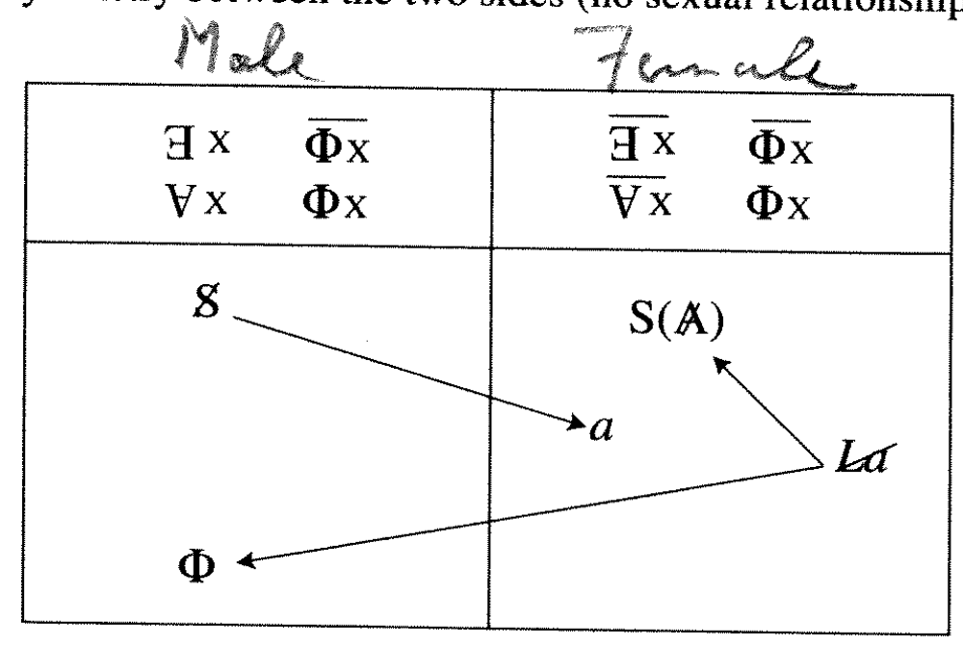

Framework: Sexual Difference Can’t Be Symbolized

Sexual position is determined by the subject’s relations to the signifying phallus. Hence, sexual difference can be conceived of only symbolically, and it is impossible to signify sexual difference.

Evans 1996.

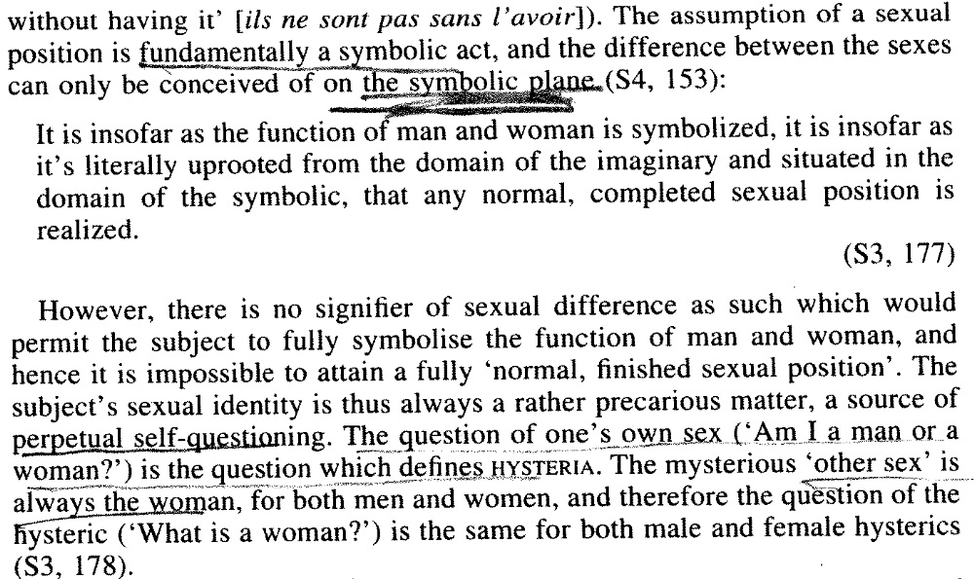
[Dylan, An Introductory Dictionary of Lacanian Psychoanalysis (London: Routledge) 178-179//jdg-wfi]
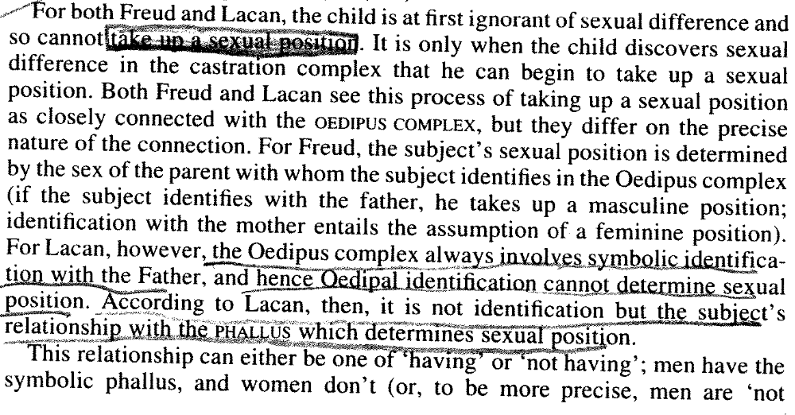

Framework: Sexual Difference Can’t Be Symbolized

The subject’s sexual position can only be realized on the symbolic level because reproduction is not symbolically represented.
Evans 1996.
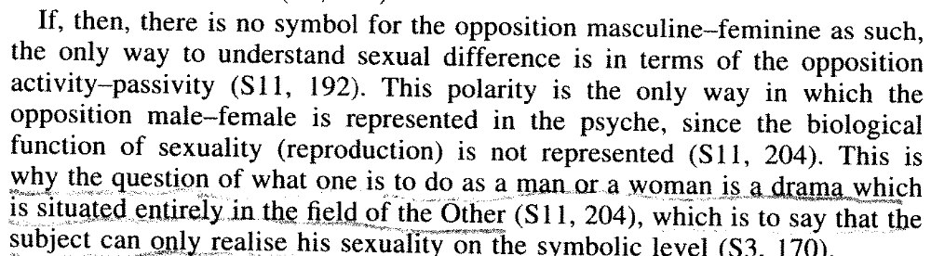
[Dylan, An Introductory Dictionary of Lacanian Psychoanalysis (London: Routledge) 180//jdg-wfi]

Framework: Sexual Difference Can’t Be Symbolized

There is no relation between the sexes because the symbolic order that stands between the two subject positions is fundamentally asymmetrical.
Evans 1996.
[Dylan, An Introductory Dictionary of Lacanian Psychoanalysis (London: Routledge) 181-182//jdg-wfi]

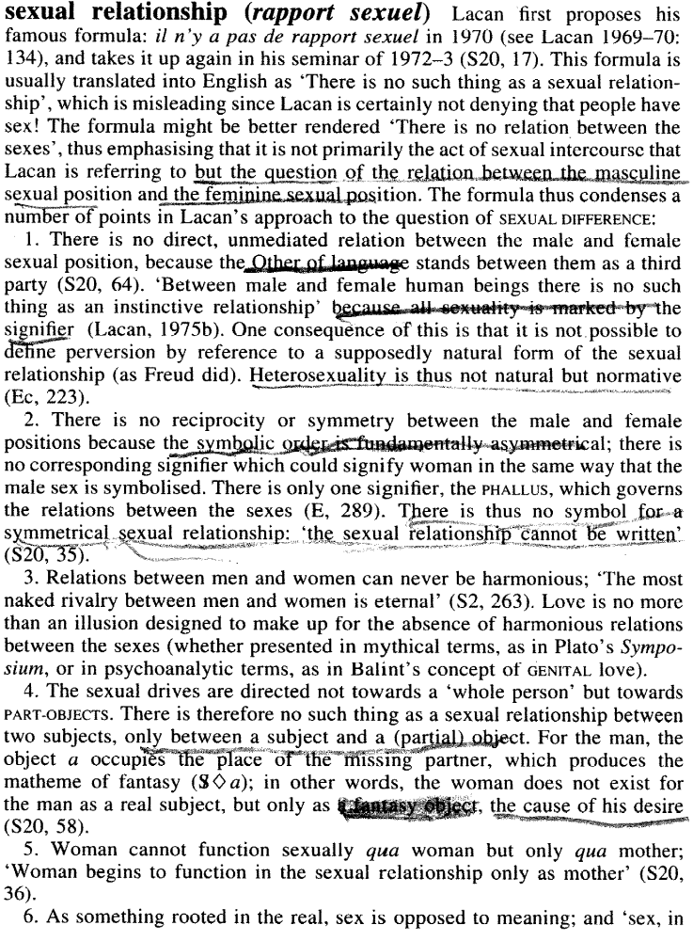

Framework: Fem. and Masc. Positions Asymmetrical

The dissymmetry in the signifier of sexual difference is the source of the dissymmetry of the Oedipal complex in men and women.
Evans 1996
[Dylan, An Introductory Dictionary of Lacanian Psychoanalysis (London: Routledge) 179-180//jdg-wfi]
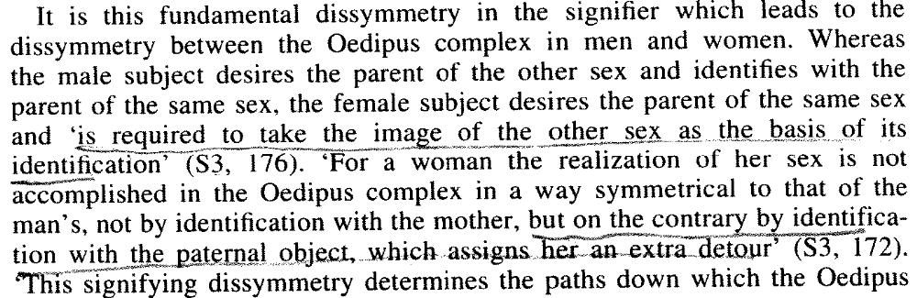

Framework: Fem. and Masc. Positions Asymmetrical

Both sides of Lacan’s formalized logical expression of sexual difference both affirm and negate absolute non-phallic jouissance, but no relationship between the two sides is possible.
Evans 1996.
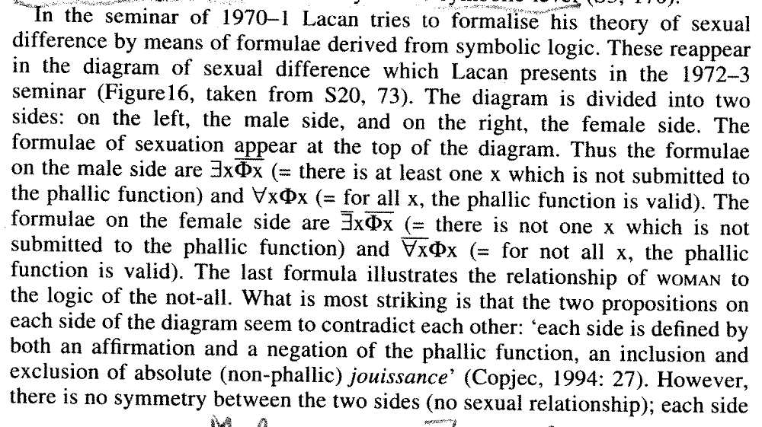
[Dylan, An Introductory Dictionary of Lacanian Psychoanalysis (London: Routledge) 180-181//jdg-wfi]

Framework: Fem. and Masc. Positions Asymmetrical

Lacan’s violation of the rules of predicate logic demonstrates that the formulae for the masculine sexual position are not inter-derivable with the formulae for the feminine position, showing the impossibility of a commensurable and symmetrical relationship between the sexes.
Freiberger 1998.
[Erich, Ph.D., Boston College, “The Cross Dressing of Logic,” Society for Phenomenology and Existential Philosophy, Georgetown University, October 11, 1996, p. 2-3//jdg-wfi]
This unusual restriction of the negation permits us to specify the sense in which Lacan is reading these formulae, for even as we find Lacan abandoning conventional logical syntax, we can still trace the manner of his variation from the norm in a way that is highly instructive. Because the negation of either an existential or universal quantifier which is itself followed by a negation is identical to its opposite, it might at first appear that the diagonal opposites in Lacan’s schema mean almost the same thing. In other words, because ‘there is not one which is not’ is convertible into ‘all’ [i.e., - ∃x - <=>∀x ], and ‘not all x are not’ is convertible into ‘there is at least one’ [i.e., - ∀x- <=> ∃x], it might appear that 1 is interderivable with 4, and 2 is interderivable with 3. [e.g., it might appear that ∃x (-Φx) <=> (- ∀x) Φx and ∀x Φx <=> (- ∃x ) (-Φx)]. If we could remove Lacan’s restriction of the scope of the negation, and apply them to the formulae as a whole, this would indeed be the case. But Lacan’s idiosyncratic use of this notation is specifically designed to exclude the possibility of such a symmetrical and commensurable relation between the sexes.

Framework: Language Castrates

The subject is symbolically castrated upon becoming a speaking being.
Salecl 2005.
[Renata, Senior Researcher at Institute of Criminology, Faculty of Law, University of Ljubljana, Slovenia, “WALTER BENJAMIN AFTER THE 20TH CENTURY: THE FUTURE OF A PAST: WORRIES IN A LIMITLESS WORLD,” Cardozo Law Review, 26 Cardozo L. Rev. 1139, February 2005, ln//lh-jdg]
One of the cornerstones of Lacanian theory is the idea that the subject, by becoming a speaking being, goes through the process of symbolic castration and becomes marked by a lack. It is through the father that castration is passed on to the child. It is not that the father is a castrating figure. The agent of castration is very language. It is the signifier that prohibits some primordial jouissance by replacing the thing with a word. The role of the father is to be the agent of the signifier, i.e., he "utters" the prohibition. However this prohibition does not come into being via a simple father's "No!" that limits the close relationship between a mother and a child. For the prohibition to be installed the actual father does not even need to be present, since what is crucial is the way prohibition is part of the very discourse with which a mother (or another primary caregiver) addresses the child. That is why Lacan when referring to symbolic law uses the term the Name-of-the-Father. Although in patriarchal culture it is often the father who is the transmitter of the symbolic law, the father actually does not embody this law. Symbolic law, which "castrates" the subject, is effectively linked to the way language operates on the subject and the father is only a transmitter of this operation. But it is crucial that the father is castrated [*1147] too. Thus in the final instance the father is the agent of castration only in so far as castration passes through him. However, if the actual father is not present, or if he in no way represents symbolic law, things might not turn bad for the subject as long as there are other ways through which the child becomes marked by the symbolic law (i.e., mother's discourse or the influence of other significant people in the child's life).

Link: Choice

The explosion of information fails to provide the certainty of the big Other that we search for.
Salecl 2005.
[Renata, Senior Researcher at Institute of Criminology, Faculty of Law, University of Ljubljana, Slovenia, “WALTER BENJAMIN AFTER THE 20TH CENTURY: THE FUTURE OF A PAST: WORRIES IN A LIMITLESS WORLD,” Cardozo Law Review, 26 Cardozo L. Rev. 1139, February 2005, ln//lh-jdg]
French psychoanalyst, Charles Melman, sees the change in subjects' perception of the Big Other as being related to the overwhelming assumption that the world is rationally organized. This assumption is also behind the idea of rational choice. The domain of the Big Other seems to be flooded with information which is supposed [*1149] to help people make choices in their lives. However this expansion of information paradoxically increases people's dissatisfaction. Melman's pessimistic conclusion is that the perception of rational organization of the world sometimes brings people to the point of not leaving any space for alterity of the Other - or better a space where there is no Big Other at all.

Almost a decade ago, two other French psychoanalysts, Jacques Alain Miller and Eric Laurent, also speculated that there is no Big Other anymore in today's society and that today's obsession with various ethical comities attest to this change. n21 Scientific development opened many questions and there are no authorities on which one can rely for answers, which is why we create various temporary, ad hoc structures (like committees). The latter are supposed to help us in dealing with the inconsistency of the Big Other, but they, of course, always fail in providing the certainty we search for. However, are we truly to be so pessimistic about the structure of the social order in which we live?

Link: Capitalism

The Capitalist transformation of the proletarian slave into the free consumer ultimately forces the subject to identify with the Master and leads to drug use and alcoholism.
Salecl 2005.
[Renata, Senior Researcher at Institute of Criminology, Faculty of Law, University of Ljubljana, Slovenia, “WALTER BENJAMIN AFTER THE 20TH CENTURY: THE FUTURE OF A PAST: WORRIES IN A LIMITLESS WORLD,” Cardozo Law Review, 26 Cardozo L. Rev. 1139, February 2005, ln//lh-jdg]
In the early seventies, Lacan made an observation that in a developed capitalistic system, the subject's relationship to the social field can be observed to form a particular discourse. In this "Discourse of Capitalism," n18 the subject relates to the social field in such a way that he or she takes him or herself as a master. The subject is not only perceived to be totally in change of him or herself, the subject also appears to have power to recuperate the loss of jouissance. In capitalism, the subject is thus perceived as an agent who has enormous power.
What does it mean that the subject is placed in the position of such an agent? First, it looks as if this subject is free from subjection to his history and genealogy and thus free from all signifying inscriptions. This seems to be the subject who is free to choose not only objects that supposedly bring him or her satisfaction, but even more the direction of his or her life, i.e., the subject chooses him or herself.
[*1148] Lacan points out that one finds in the "Discourse of Capitalism" rejection or better foreclosure of castration. This foreclosure happens when society more and more functions without limits and where there seems to be a constant push towards some kind of limitless jouissance. This push to jouissance at all costs is especially visible in all forms of toxic mania - from excessive consumption of alcohol, drugs, shopping, workaholism, etc. n19 Capitalism more and more transforms the proletarian slave into free consumer. However, limitless consumption paradoxically provokes the moment when the subject starts "consuming himself."
And although the subject in "Discourse of Capitalism" is perceived as being totally in charge or him or herself and especially free to make numerous choices, one sees a paradoxical trend that this possibility of choice opens doors to an increase of anxiety. One of the ways to deal with this anxiety becomes strong identification with the master. The latter allows the subject to relinquish his or her doubt, to avoid choice and responsibility, and thus in some way to find a relief for his or her own existence.

Link: Liberal Society

While the true self is increasingly self-made, the self’s decisions are made unconsciously, and the choice of liberal society is actually false.
Salecl 2005.
[Renata, Senior Researcher at Institute of Criminology, Faculty of Law, University of Ljubljana, Slovenia, “WALTER BENJAMIN AFTER THE 20TH CENTURY: THE FUTURE OF A PAST: WORRIES IN A LIMITLESS WORLD,” Cardozo Law Review, 26 Cardozo L. Rev. 1139, February 2005, ln//lh-jdg]
"Be yourself!" In the Western world people are not only under the impression that there are endless possibilities to find fulfillment in life, but they are also encouraged to be some kind of self-creators, i.e., they are supposedly free to choose what they want to be. In this highly individualized society, which allegedly gives priority to the individual's freedoms over submission to group causes, people, however, face an important anxiety provoking dilemma: "Who am I for myself?" [*1141] The answer to this question is in no way simple, which is why there is a huge advice industry, which tries to guide people in their search for their "essence." On the cover of a recent Cosmopolitan magazine, we can thus read a promise that the magazine will help you to: "Become yourself, only a better one"; on the Internet various astrology sites provide free samples of insight into the "Real you"; and on television one can undergo a total body makeover which is supposed to allow people to forge a body image in which they will feel comfortable with themselves. President Bush was reported to have said: "I know who I am, and I want to become who I am." The self is something to be aspired to, like the latest fashion or the latest consumer object. Self-aspiration and the created self are seductive. The winner of the most recent Big Brother contest in the U.K. was a Portuguese transgender woman, Nadia Almada. When she was told that she had won, her response was "Now I am recognised as a woman." One question is why Nadia found such popularity with British television audiences. It seems from anecdotal evidence that what many voters found seductive was the project of a self-journey, the realization of a desire to make something completely different of oneself. With her self-transformation, she seemed to embody for the audience the ideology of self-creation that underpins today's consumerist society. It is perhaps not surprising that psychoanalysts report that they are encountering numbers of people who come into analysis with the demand: "I want to reinvent myself." However, in this attempt to remake oneself and become someone unique, one can easily observe a pattern of sameness. Walter Benjamin already envisioned this move towards sameness when he observed that: The commodity economy reinforces the phantasmagoria of sameness which, as an attribute of intoxication, at the same time proves a central figure of semblance... . The price makes the commodity identical to all the other commodities that can be purchased for the same amount. The commodity empathizes ... not only and not so much with buyers as with its price. n5 This phantasmagoria of sameness can easily be perceived in the way the ideology of "self-creation" actually functions. Although people are constantly reminded to make out of themselves what they want, they are actually following ideals of sameness. One only needs to look at the results of body make-overs that one can observe on television, and one gets a confirmation that for the price one pays to get a new body, one actually purchases a body image that everyone else adheres to. The ideology that promotes the motto "Be yourself!" and relies on the Nike ad, "Just do it!" also encourages the idea that people need to be [*1142] able to "manage" themselves. One is constantly reminded by the dominant media to work on relationships, n6 on parenting, to become a better person and especially to manage one's emotions. A simple search on amazon.com in regard to how to deal with an emotion like anger gives us a list of 95,000 books that deal with this issue. A quick look at the titles gives the impression that anger is a huge problem in today's society. We seem to live in "The Trap of Anger," are dealing with "The Dance of Anger," "Anger Kills," there is "The Enigma of Anger," which causes "Anger Disorders"; and there are "Angry Women" who seem to experience rage differently than men. But especially important is "Helping Your Angry Child" to become "anger-free." However, most of the books offer advice on how to get rid of angry feelings. "Anger Management," "Overcoming Anger," "Beyond Anger," "Conquering Anger, Letting go of Anger," "Anger Control, Healing Anger, Working with Anger, Taking Charge of Anger" are only some of the titles of books that are supposed to help us deal with this emotion. But the next step is to "Honour your Anger," to go "From Anger to Forgiveness," and especially to realize that "Anger is a Choice." The idea that we are supposed to be able to manage ourselves and that there is a choice in how we deal with our emotions is linked to the very perception of the self that dominates late capitalist society. Today, the true self is increasingly self-made, and more than that, an individual project. In the 1980s and 1990s, drawing on the work of Michel Foucault, n7 academic theories emphasized the social construction of the self. However, now self construction has become a cultural imperative in the West, and the emphasis is not on social determinations, but on the individual project of self-making. This is related to what Ulrich Beck n8 and others have called "individualization." While individualization takes many forms, it always involves a "fetishization" of the autonomous self, one that refuses to acknowledge the idea that society can set limits on self-aspiration. Paradoxically, the ideology of a limitless world is itself a product of late capitalism and the relentless drive of consumer society with its emphasis on endless choice and possibility. If, on the one hand, we live under the assumption that everything in life can be a matter of choice - on top of consumer and usual political choices, we can choose not only how we look, but our sexual orientation, whether or not to have children, what kind of medical [*1143] treatment we want, etc. - on the other hand, the very choice itself seems to be anxiety provoking n9 and deeply dissatisfying. n10 That is why we often hear in the popular media that our society actually suffers from so-called tyranny of choice and an abundance of freedom. Existentialist philosopher and novelist, Albert Camus, nicely described how everything in life is a matter of choice when he posed the question: "Shall I kill myself or have a cup of coffee?" It is not simply that our existence is defined by the choices we make in our lives; our very existence is itself a matter of choice. In regard to life choices, Freud has made quite skeptical comments. When his friend asked him for advice about whether he should marry a particular woman, Freud allegedly said that when it comes to small matters in life, one should think long and hard before making a decision, but when it comes to the big one, like to marry or not, to have children or not, one should just do it. One can speculate that no matter what we rationally choose in these circumstances, we will never be able to determine the outcome of our behavior since the unconscious will always guide us on paths that we cannot control.

Link: Happiness

Looking for happiness is a waste of time, since we’ll never find it. It’s far better to be happy about being unhappy.
Salecl 2005.
[Renata, Senior Researcher at Institute of Criminology, Faculty of Law, University of Ljubljana, Slovenia, “WALTER BENJAMIN AFTER THE 20TH CENTURY: THE FUTURE OF A PAST: WORRIES IN A LIMITLESS WORLD,” Cardozo Law Review, 26 Cardozo L. Rev. 1139, February 2005, ln//jdg-wfi]
Will Fergusson in his novel Happiness n1 envisions our society finally becoming truly happy. This happens after people become mesmerized with a particular self-help book, which in the most compelling way offers advice on how to achieve true self-fulfillment in life. The small book becomes like a virus, which continuously spreads around society. People who read it suddenly abandon their previous lives, simplify their clothing, stop buying expensive cosmetics, stop obsessing about changing their bodies with the help of plastic surgery, cancel their subscription to gym, give up cars and all other usual consumerist possessions, and abandon their old jobs by placing on their office doors a note: "Gone fishing!" These newly awakened people brim with happiness - their faces look relaxed, they constantly smile, their bodies move in a joyful way, and their whole demeanor exults serenity and contentment. When masses of people become truly happy, capitalism falls into deep trouble. Industries start collapsing one by one. Deeply worried, the publisher of the book and the leading capitalists decide to find a way to stop this happiness movement. They start searching for the author of this dangerous self-help book. Soon it is revealed that the writer is not an Indian guru as was stated in the book, but an old loner who lives in a trailer park. When this man learned that he had cancer, he decided to provide financial legacy for his grandson by writing a book, which in essence combines all the major ideas of already existing self-help books. The story ends when the publisher convinces the old man that his writing did more harm than good for the progress of society. The author is then encouraged to write a new book on how to be miserable so capitalism can again flourish.
People often come to psychoanalysis in order to find happiness in their lives and they imagine that the analyst is a happy person. If [*1140] psychoanalysis is supposed to provide a cure for unhappiness, then the analyst must have been cured from this pathology in order to help the patient. To such expectations, Jacques Lacan, mischievously adds: "It is a fact that we / the analysts / do not disclaim our competence to promise happiness in a period in which the question of its extent has become so complicated: principally because happiness, as Saint-Just said, has become a political factor." n2 But then Lacan concludes that: "It is a waste of time ... to look for the shirt of a happy man, and what is called a happy shadow is to be avoided for the ills it brings." n3
The novel Happiness envisioned that a truly successful self-help book would bring capitalism to an end, since it is precisely capitalism that constantly encourages us to assess our current state of happiness and, of course, search for more of it. Walter Benjamin took capitalism as a form of religion; as a celebration of a cult, which very much plays on the feeling of guilt. His point is that "worries" become mental illness characteristic of the age of capitalism. n4 What kind of worries are we concerned with today? Does Benjamin's prediction that feelings of guilt are a crucial part of capitalism hold true today? Or is something changing at the start of the 21st century?
Benjamin had a conflicting relationship with psychoanalysis; however, looking at the nature of worries and guilt today very much demands our attention to what psychoanalysis says about the way capitalism affects subjectivity. This article will look at the issue of worries in the context of the logic of social prohibition that we encounter in late capitalism. Today it appears that, on the one hand, people are encountering fewer and fewer external prohibitions which in the past were transmitted with the help of traditional authorities (like father, state, or church leaders, etc.) while, on the other hand, people are imposing ever new prohibitions on themselves.

Link: Search for Good

The attempt to find good is a barrier to desire. The notion of good obscures the analytic situation, is controlled by the symbolic order, and prevents an examination of desire. The “cure” is to know the absolute disarray into which our desire leads us.
Caudill 1995.
[David, Assistant Professor of Law, Washington & Lee University, “Law and the Postmodern Mind: Lacanian Ethics and the Desire for Law,” Cardozo Law Review, 16 Cardozo L. Rev. 793, ln//lh-wfi]
On first reading of the Seminar on the Ethics of Psychoanalysis, a topic that might seem amenable to clarity and organization, Lacan is evasive and ambiguous. The text is a wide-ranging and disjointed account of the analytic situation, n21 and of moral philosophy with reference to Plato and Aristotle, to Georg W.F. Hegel [*797] and Jeremy Bentham, and to Immannuel Kant and the Marquis de Sade; n22 along the way, Lacan explicates six or eight Freudian categories, n23 a few episodes from art history, n24 the text of Antigone, n25 and the nature of beauty n26 and even of religion. n27 It is easy to believe that the project is unfinished and that twelve years after the Seminar Lacan - although he didn't write books - wanted to write one on ethics. n28 He never did. In briefest terms, the Seminar is a sustained critique of any ethical theorizing that begins with an attempt to define the good, or the sovereign or supreme good. n29 For Lacan, the appropriate starting point for ethical reflection is the desire of the subject, n30 thus his critique of various notions of the good is constructive. Several times in the Seminar, Lacan refers to the good as a barrier to desire. n31 If that sounds commonplace, insofar as ethics is often viewed as a corrective to desire, I should confirm that Lacan's view is quite to the contrary. There are at least four less obvious senses in which the barrier metaphor is employed, and by describing each I hope to highlight one theme of the Seminar of interest to legal theorists. First, the notion of the good, whether described in terms of a natural order or in terms of pleasure or happiness or wealth, is a [*798] barrier to theoretical discourse because it functions to support ethical reflection that does not attend to a preliminary or foundational matter: to give an account of desire. n32 Of course, Lacan does not say that any old account of desire will do - he is critical of both the view that desire is bad and must be controlled in the name of law, and the view that desire must be liberated in the name of pleasure. The first view fails to recognize the mutual bond between desire and law, that is, the manner in which law makes transgression possible as well as the manner in which the law of desire is prior to and beyond morality. n33 The second view, toward liberation, fails historically: the more the theory, the more social criticism, and the more duties we can imagine with which to burden the liberated subject. n34 Freud's pleasure principle, at least, revealed a system that tends toward deception, toward a hallucinating satisfaction that requires a reality principle to correct and restrain the instincts. n35 The second sense in which the good is a barrier to desire is in the analytic situation - against the view that psychoanalysis is a moralizing discourse, Lacan confirms that the analyst does not deliver virtue, but rather clears pathways and then, perhaps, hopes for virtue. n36 Surely an ethical judgment is in play here, but the goal is to reveal or to let the subject reveal his or her desire, not to help [*799] the subject colonize his or her lack with mirages of other happy people, or with his or her "own good," or even society's good. n37 The "cure," if that's the right word, is to know and experience the absolute disarray into which our desire leads us, to know the human condition. n38 If that sounds pessimistic, Lacan anticipates the criticism of a gathering of leftist intellectuals. Calling upon the images of the fool and the scoundrel in Elizabethan drama, Lacan concedes that right-wing intellectuals are scoundrels in their appeal to the reality of the human condition, but he also notes that a gathering of right-wing intellectuals leads to collective foolery. n39 Leftist intellectuals, on the other hand, are innocent fools in their optimism, but gathered together, they trick each other into believing that progress does not require enormous costs. n40 The third sense given to the good as a barrier to desire is not so different from the first two senses (that the good is misleading in (1) theoretical and (2) analytical discourse), and it is the third sense that allows the editor to promise that the Seminar clarifies many of Lacan's key concepts: the good is a signifying construction, and is structured by, rather than giving structure to, the symbolic order. n41 Just as psychical functions are revealed (after some effort) in symbolic processes, the desire of the subject is revealed, though never completely, in the subject's relationship with language. n42 Moral law is an after-effect, a trace or oversimplification, of desire. n43 [*800] The fourth and final sense in which the good is a barrier to desire is as a description of the structure or law of the desiring subject. Lacan remarks that the "sphere of the good erects a strong wall across the path of our desire," and then suggests that the field of ethics is beyond, rather than exemplified by, that wall. n44

Link: Search for Good

Creon’s attempt to provide for the good of all takes the masculine sexual position. Antigone, however, aims beyond the good, taking the feminine position by experiencing the jouissance of the real.
Caudill 1995.
[David, Assistant Professor of Law, Washington & Lee University, “Law and the Postmodern Mind: Lacanian Ethics and the Desire for Law,” Cardozo Law Review, 16 Cardozo L. Rev. 793, ln//jdg-wfi]
I realize that my aphorisms do not do justice to his ethical inquiry; I can, however, perhaps as a continuation of a theme in the opening address to this symposium, n50 highlight a move that Lacan makes toward the end of the Seminar that should be of interest to [*801] those in law. Lacan offers a reading of Antigone that he hopes can derail our imaginary preoccupations with the good as the starting point for ethical reflection. n51 The obvious conflict between Antigone's law and the law that the community thinks is just can help us see and define desire - the catharsis of the tragedy can be our own purging. n52
If Creon seeks the good, the good of all, Antigone's desire aims beyond the good. n53 When she is caught, the law of Creon brings tragedy all around. n54 For Lacan, Antigone is not in the legal community, but in the field of the Other - she leaves written law behind and appeals to the law at the limit; she goes back to the point where language enters the subject, to the kingdom of the dead, where she exemplifies desire before it is articulated in the symbolic. n55
After his commentary on Antigone, Lacan returns, at the very end of the Seminar, to the analytic situation - which is not intended to put the subject in a position where everything works out for the good. n56 To terminate an analysis with comfort and to guarantee a cultural dream-of-the-moment is fraud. n57

Link: Search for Good

The quest for the good and the just is an attempt to arrive at a particular social and political arrangement of power.
Douzinas 1995.
[Costas, Sr. Lecturer in Law, Birkbeck College, U of London, “Law and the Postmodern Minid: Law’s Birth and Antigone’s Death: On Ontological and Psychoanalytic Ethics,” 16 Cardozo L. Rev. 1325, ln//jdg-wfi]
The Good is the starting point of the attempt to come to terms with the subject's destiny. Lacan approaches the question of the Good as an economic problem, as the question of access, distribution, and enjoyment of goods. Goods, products of labor, and depositories of value satisfy human needs and increase pleasure. As philosophers have been unable to distinguish good from bad pleasures, they have concentrated on separating the true from the false goods to which pleasure points. The theory of the Good has always been a disguised or explicit attempt to arrange the production and distribution of goods, and forms a bridge between the pleasure and reality principles. Ethics, in this sense, has always been a hedonism and the whole Western tradition in ethics found its culmination and telos in Bentham. The quest for the Good is therefore caught in a profound duplicity captured by the double meaning of the classical conception of praxis. On the one hand, praxis means ethical action, synergia, practical life in conjunction and cooperation with others; but secondly, praxis leads to an ergon, an aim or goal in the sense of a product, or a good produced. [*1332]
Lacan makes the second meaning dominant and interprets theories of the Good in economic terms. Propriation and control over one's goods deprives others. The Good is therefore not just an answer to a natural need but also a power, the power to satisfy through the privation of the Other. Our relation to goods is arranged so as to take account of the basic fact that the Other has the power to deprive me of the Good. Every time the ego chooses to do good, something beyond the Good, "something completely enigmatic appears and returns to us again and again from our own action - like the ever-growing threat within us of a powerful demand whose consequences are unknown[.]" n12 The ego ideal represents the field of the Good and opens/bars the terrifying beyond it, while the ideal ego is the threatening Other. The Good brings together an economy of satisfaction and privation in the hands of the imaginary Other who acts as the depriving agent and thus bars entry to the locus of jouissance. Control over goods is also control over people; the Good is linked with the creation and exercise of power. The theory of the Good(s) is closely linked, if not identical, with one type of the quest for justice, presented as a political and social arrangement of power based on the (equitable) distribution of goods.

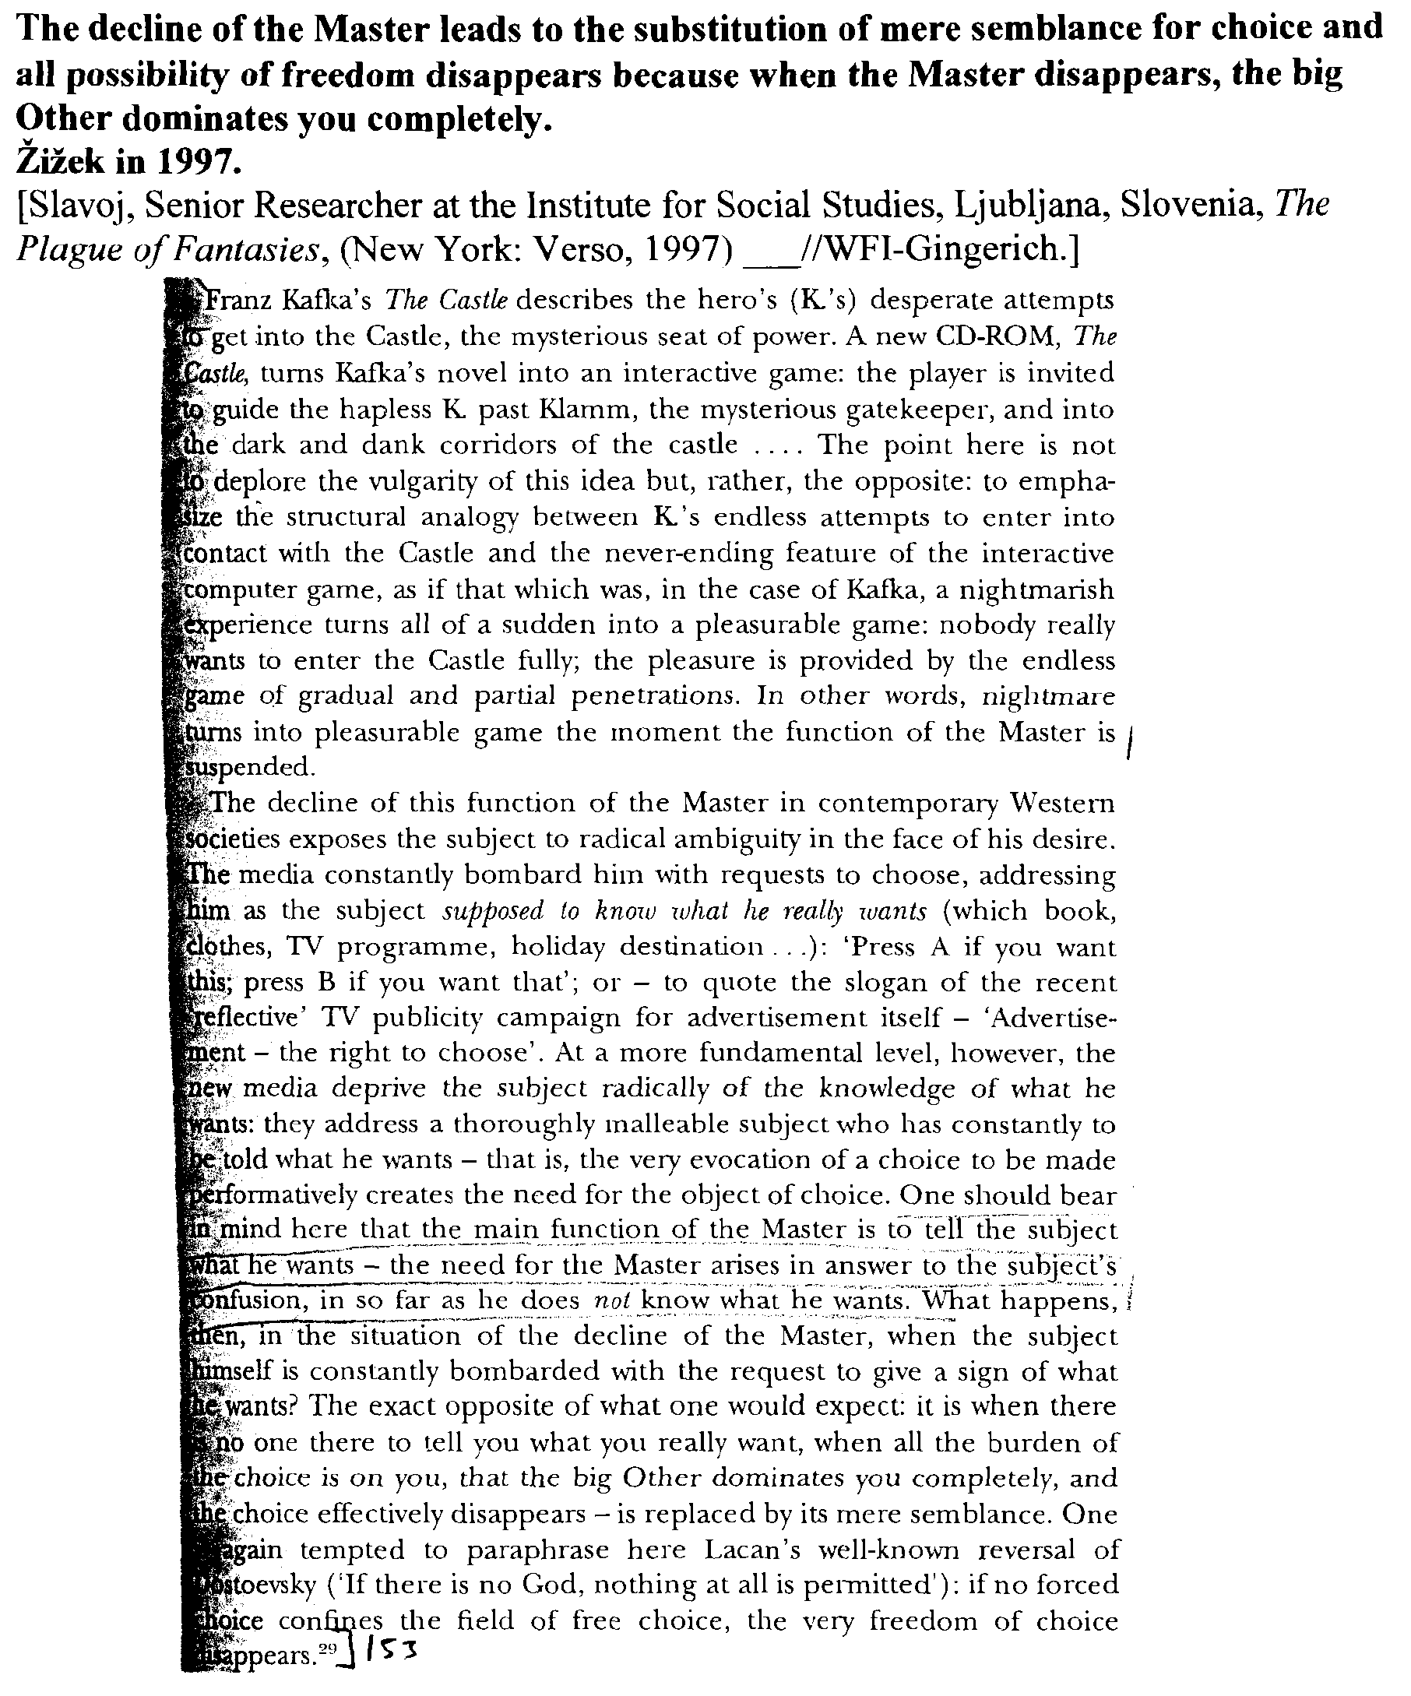
Link: Suspension of Master

Link: Language

Language is the imperfect form of communication, the flaw being that human ideology is sculpted to state that only things within the confines of language can exist.
Salecl 1995.
[Renata, philosopher and sociologist, working as a researcher at the Institute of Criminology, Faculty of Law, University of Ljubljana, “Law and the Postmodern Mind: Rights in the Psychoanalytic and Feminist Perspective,” Cardozo Law Review, 16 Cardozo L. Rev. 1121, ln//jc-wfi]
The universality of human rights and their abstract character are necessary for the functioning of democratic society. It is equally essential that this universality remains empty, without content. Because human rights possess this kind of universality, they function in the same way as Lacanian mathemes. A matheme is something that can be inscribed, constructed at some Real place, but whose content cannot be defined or displayed in reality. A matheme is an inscription which cannot be translated and always remains the same because it does not have a meaning in itself.
Lacan describes what he means by a matheme by invoking the difference between the meaning of the words "exist" and "ex-sist" (or insist). Something can exist only if it can be articulated in language. But what only ex-sist or insist (and belongs to the Real) cannot be described in language. This is true, for example, for the objet a - it can only be inscribed, formulated in "quasi logical-mathematical" terms. And this is also true for human rights. As long as they are only a construct, an empty universality, human rights as such do not exist, they can only "insist," i.e., as a substitute for something fundamental which the subject has lost; thus, they belong to the Real. Similarly, human rights can never be fully described in language, as there will always remain a gap between positive, written rights, and the universal idea of human rights.

Link: Rights

Democracy can never measure up to the substantiality of human nature. Attempting to fill in democracy with human content risks falling into totalitarianism. Human rights are the essence of democracy because they are grounded in the abstract individual. Making rights concrete renders them meaningless and forces society to search for new rights.
Salecl 1995.
[Renata, philosopher and sociologist, working as a researcher at the Institute of Criminology, Faculty of Law, University of Ljubljana, “Law and the Postmodern Mind: Rights in the Psychoanalytic and Feminist Perspective,” Cardozo Law Review, 16 Cardozo L. Rev. 1121, ln//jc-wfi]
The relevance of Kantian philosophy for understanding the notion of human rights can be shown on another level. The Kantian notion of the abstract, empty subject can be used to establish the theoretical basis for democracy. The essence of democracy is that it can never be made to the measure of concrete human beings; the basis of democracy is the subject as a pure empty place. Democracy is always only a formal link between abstract subjects. As soon as we try to fill it out with concrete, "human" content, we risk falling into totalitarianism. And the same goes for human rights: as an answer to the question, "Who is the subject of human rights?", we can only say that here, too, we find the empty subject, the cogito.
Marx's critique of the notion of human rights centered on precisely this abstract character of its bearer, the abstract subject which lies at the core of the idea of human rights. Marx saw the notion of human rights as a product of bourgeois ideology that, by establishing the abstract categories of human equality and freedom, tried to mask existing relations of domination in capitalist society and the actual inequality and "unfreedom" of concrete individuals. But as Claude Lefort argues in his critique of Marx, n4 the very opposite is true: human rights are one of the essential elements of democracy precisely because they are grounded on the idea of the abstract individual. The contribution of human rights to democracy lies in the fact that human rights can never be totally defined, that their character cannot be determined in full, and that they cannot be enumerated. Thus society needs to continually invent new rights. For Lefort, the very fact that it is impossible to determine the character of the bearer of human rights is what gives the idea of rights its critical potential: "The rights of man reduce right to a basis which, despite its name, is without shape, is given as [*1124] interior to itself and, for this reason, eludes all power which would claim to take hold of it - whether religious or mythical, monarchical or popular." n5 As a result, for Lefort, such rights extend beyond any formulation imposed on them. In fact, "their formulation contains the demand for their reformulation" - nor are acquired rights "necessarily called upon to support new rights." n6 Thus Lefort concludes, rights "cannot be assigned to a particular period, as if their meaning were exhausted by the historical function they were called upon to fulfill in the service of the rising bourgeoisie, and they cannot be circumscribed within society, as if their effects could be localized and controlled." n7
Lefort strongly opposes theorists who perceive the notion of human rights as some kind of relic from the past, long stripped of its significance. He stresses that human rights, because of their abstract character and indefinability, cannot be situated in a specific historical era. This means that they cannot be genealogically analyzed, as Foucauldians would like, nor can their effects be measured or controlled. The concept of human rights therefore retains its potential to critique actual historical circumstances as long as it remains an empty, universal idea. Thus, while it is a mistake to place the idea of human rights in a specific historical context (as historicists try to do), it is also useless to search for some intrinsic human nature at the core of the idea of human rights (as natural rights theorists try to do). Marxists and Foucauldians make a similar mistake in rejecting the notion of human rights. When Marxists perceive human rights as an abstract idea masking real social antagonisms, and when Foucauldians consider human rights as a historically determined discursive praxis entrapped in the game of power, both camps miss the point that the abstract idea of human rights establishes the locus within which a split between law and power first arises. Human rights mark the point at which the all-encompassing power of political institutions is suddenly negated.

Link: Rights

Submission to a legal system of rights is submission to the function of castration. For this reason, rights are always insufficient, and we must always seek to create new rights perpetually. However, because rights serve the function of the objet a, this search is in vain.
Salecl 1995.
[Renata, philosopher and sociologist, working as a researcher at the Institute of Criminology, Faculty of Law, University of Ljubljana, “Law and the Postmodern Mind: Rights in the Psychoanalytic and Feminist Perspective,” Cardozo Law Review, 16 Cardozo L. Rev. 1121, ln//jc-wfi]
Human rights in the modern sense of the term can only appear within the space of intersubjectivity established by the Kantian cogito. Before Kant, rights were defined vertically and were understood as granted by some power beyond human beings (God, for example). With Kant, rights became established horizontally: the rights of one individual are defined in opposition to the rights of another. n24 The point is that the rights of another individual do not only limit our rights but also define them. When we perceive another individual as someone who has rights, we recognize him or her as the agent who defines what we are, what kind of rights we have. Linked to this is the question, why did the notion of human rights appear only in eighteenth-century bourgeois society and not before? The invention of democracy brought with it the notion of a forced choice and a sacrifice the subject had to make in order to become a member of the community. The social contract, which incorporates the subject into the symbolic community, is linked to [*1133] the subject's having to make a choice: the subject has to choose freely to become a member of the community, but this choice is always a forced choice - if the subject does not "choose" community, it excludes itself from the society and falls into psychosis.
With the help of Lacanian psychoanalysis it can be said that through this ritual of the forced choice the subject undergoes symbolic castration and actually sacrifices the incestuous Object that embodies impossible enjoyment (but as Lacan says, the paradox is that this Object is not given prior to its loss, and that it only comes to be through being lost). Before the invention of democracy when the social community still functioned as an enlarged family, this sacrifice did not exist in such a way: the subject was naturally linked to the community (the subject was by nature a social being, zoon politikon, in Aristotle's terms) and did not need to freely accept it. In premodern society, the subject's "entering the society" was not such a traumatic act of choice and sacrifice, because in this hierarchic society, the subject became included in the society by an act of initiation. Although the subject underwent castration in pre-modern society, castration became visible only by the invention of democracy. The same logic is, on another level, at work with the notion of the "empty place of the power," introduced by Claude Lefort. We cannot say that the place of power became empty only with the invention of democracy. The place of power was already empty: but with democracy this emptiness became visible, while before, it was masked by the presence of the monarch.
The introduction of rights is nothing other than a substitute for the fundamental prohibition to which the individual is submitted upon becoming a social subject. As such, rights serve the same function as the Lacanian notion objet a, the object cause of desire. The objet a is the substitute the subject gets when it is subjected to castration upon entering the realm of symbolic mediation. At the same time, however, the objet a is also the element that renders all other potential substitutes insufficient. For example, when the child is weaned from the breast and loses its primal object of desire, every other object will be seen as a substitute, as something to fill out this place of the primary lost object. Desire will therefore range from one object to another but will always remain unsatisfied, it will always be a "desire for something else" insofar as these new objects are seen as substitutes for the first object. n25 Thus, on the one hand, the objet a fills the lack, the split that traverses the [*1134] subject after castration, but, on the other hand, the objet a prevents any object from really filling this lack. The same goes for rights: although we get them as a substitute for the fundamental prohibition necessary to live in a society, rights actually prevent any substitute from filling the lack which was introduced by the prohibition. Although we have rights, a right that would express the notion of rights itself does not exist. All we can do, in this regard, is to invent new rights perpetually, searching in vain for a right that would affirm us as nonsplit subjects.

Link: Rights

The phallic function psychically castrates subjects as they enter language, but women do not “exist” within the symbolic terms of language. Attempts to universalize human rights are the work of the dominant “male” logic of the formulae of sexuation—in order for nobody to remain without rights, nobody may possess them universally.
Salecl 1995.
[Renata, philosopher and sociologist, working as a researcher at the Institute of Criminology, Faculty of Law, University of Ljubljana, “Law and the Postmodern Mind: Rights in the Psychoanalytic and Feminist Perspective,” Cardozo Law Review, 16 Cardozo L. Rev. 1121, ln//jc-wfi]
By analyzing the question of the universality and the particularity of human rights with the help of Lacan's formulas of sexuation, n26 we can see how it is possible to articulate the problems of sexual difference and human rights in another way that feminist legal theory does. Through his formulas of sexuation, Lacan argues that man and woman are defined (and split) separately with [*1135] respect to the "phallic function." Lacan understands the phallic function as symbolic castration, as something that happens to a human being when he or she enters language.
Man is completely subordinated to symbolic castration and thus wholly determined by the phallic function. Man's logic is a logic of universality: the whole of a man falls under the phallic function, i.e., man is altogether determined by symbolic castration, but at the same time the position of man implies that there is one man (the Freudian "primordial father") who is an exception and is not subordinated to symbolic castration. This "primordial father," as is well known from Freud's myth, is the possessor of all women, the father who is not subordinated to the law and to whom the threat of castration does not apply. The woman's logic of the formulas of sexuation also has two parts: the first formula says that not all of a woman falls under the phallic function, and the second formula says that every woman is at least in part determined by the phallic function. For women, however, the phallic function does not govern completely. Woman, Lacan says, is in respect to the symbolic order not whole, as she is not totally bounded and determined by the phallic function. But Lacan argues that although not all of a woman is defined by the phallic function, she is nevertheless situated within the symbolic order.
When Lacan says that Woman does not exist, he means that women cannot be adequately defined through language: women have something (the presumed woman's jouissance) that escapes the symbolic order. Bruce Fink, in describing the formulas of sexuation, argues that women have more "direct" access to the Real, to that which is "unsymbolizable," around which the symbolic order is structured. n27 The Lacanian feminine logic thus presents what is particular, what is symbolized, but what also escapes symbolization.
If the idea of human rights is analyzed with the help of Lacan's formulas of sexuation, two logics can be found to be at work in it. According to the first, the currently dominant "male" logic, all people have rights, with the exception of those who are excluded from this universality (for example, women, children, foreigners, etc.). In contrast, according to the second, the "feminine" logic, there is no one who does not have rights, i.e., everybody taken individually possesses rights, but precisely because of this we cannot say that people as such have rights. This feminine logic could be [*1136] called a postmodern logic of rights. According to this model it is not the case that human beings as such have rights, but that none remain without rights. Rights as such cannot be universalized, because universalization always needs an exception: there has to be someone who does not have rights for the universal notion of rights to exist. A postmodern approach to rights would be based on the claim that no one should remain without rights, which also means that no one can universally possess them. Understanding human rights according to the Lacanian formulas of sexuation enables us to articulate a discourse of human rights that does not conceal social antagonisms, while still retaining its critical function.

Link: The Law

Psychoanalysis exposes the unconscious dependence of secular law upon speech in the name of the father.
Goodrich 1997.
[Peter, Professor of Law, Birkbeck College, University of London, “Maladies of the Legal Soul,” 54 Wash & Lee L. Rev. 1035, ln//jdg-wfi]
The social image of a divine father whose paternal authority legitimated all other laws suffuses the western legal tradition. A myriad of differing secular depictions reveals this image. The primacy of the image of the father is significant. The tradition elaborates this figure of paternity within the differing jurisdictions and laws of the polity. Regia potestas and patria potestas, the power of the king and the power of the father, are two instances or jurisdictions of the same law. Thus, law is the speech of the father or, more technically, speech "in the name of the father." n37 The same image of paternity provides the model for the social family and the domestic family and the same genealogical method authorizes these laws. According to this genealogical method, a law is legitimate if it is issued by, traceable to, or promulgated in the name of the father. Resurrecting the familial and paternal metaphor of legal governance, the psychoanalytic tradition draws upon an antiquated tradition that never recognized any meaningful distinction between the different aspects or jurisdictions of legal rule. The secularization of the legal tradition in the modern period may have attempted, in the name of reason, to mask the paternal character and figuration of legal authority. However, it does so only by repressing the history of the different jurisdictions and plural forms of law. The monotheistic culture of the legal tradition survives in modernity only by pretending to a reason that is both external and superior to the symbolic reality - the contingent and imagistic theater of its institutional history.
The myth of Oedipus and the case of Lortie are similar narratives on the primary attachment of the human subject to the social order of law. In terms of legal history, this narrative was traditionally the subject matter of canon or ecclesiastical law and its governance of the soul. Thus, the church courts and canon law originally governed the interior life of the subject. Spiritual judges monitored and exercised what were explicitly termed the ghostly powers dictating how to judge conscience and how to order the soul in conformity with God's law. Psychoanalytic jurisprudence can thus be understood initially as bringing with it the inestimable message that the legal order is still predicated both internally and externally upon images of social paternity and upon the application of legal rules in the name of the father. The Freudian tradition endeavors to make conscious a structural feature of the western legal tradition that is largely unconscious in the modern era - that images of a paternal law have consistently bound together subject and society in the West. n38

Link: Naturalization of Law

The naturalization of the law suppresses the subjectivity of the lawyer.
Goodrich 1997.
[Peter, Professor of Law, Birkbeck College, University of London, “Maladies of the Legal Soul,” 54 Wash & Lee L. Rev. 1035, ln//jdg-wfi]
According to established common law tradition, judges do not create law, but "discover" and apply it, even when deciding cases in novel areas of doctrine. n47 Where the ambit of a rule is expanded or curtailed, traditional legal wisdom holds that the judge is not inventing or embellishing law, but rather exposing the inner logic and necessity of extant norms. The modern judiciary has on occasion admitted that this notion of judicial discovery of law and correlative objectivity of judicial determinations is broadly untenable. Nonetheless, this admission has not lead to any extensive rethinking of the subjective or affective dimensions of judgment. Legal thinkers generally deem such dimensions to be imponderable aspects of an unknowable justice and not, strictly speaking, questions of law. For this reason, one of the first stylistic and semantic lessons of the legal curriculum is still that the student of law cannot write in the first person singular. The student's 'I' is instantaneously deleted or erased because law is objective and the affinities or opinions, experiences or beliefs, of the subject are deemed irrelevant and indeed heretical to the exposition and manipulation of legal rules. What is traditionally sought in the library of legal texts is authority and such authority or law is not a property of the living, but an attribute of the dead and of their texts. By the same token, living authors within the English common law tradition cannot be treated as authoritative, supposedly because the living can change their minds or contradict themselves. n48 Only dead treatise writers can be treated as having authority because only the dead parent or absent father can truly attain to the aura and absolutism of law. In Legendre's felicitous formulation, "in the epiphany of law, the jurist counts for nothing." n49
This denial of identity and erasure of personality initially poses the question of what such repression costs. It is commonplace that lawyers take no ethical responsibility for their clients and make whatever arguments best suit their case or cause. In slightly more expansive terms, the lawyer's denial of emotion and suppression of subjectivity is likely to make the lawyer at the very least emotionally dishonest and ill-equipped to deal with the realms of feeling, of fear and desire, inhabited by their clients and indeed by their non-legal contacts. In one argument, the repression that initiates legal identity slowly transforms the lawyer into an emotional incompetent, a withdrawn, abstracted, and frequently lost soul. As many critics have argued, what was initially a mask becomes the person. n50 Trained systematically to deny their feelings and trained equally to communicate with others in conflicting and antagonistic forms, the lawyer's denial of subjectivity can easily become a form of life. The company of lawyers is customarily shunned because their training encourages alienation and self-estrangement. Such lack of feeling distances the lawyer from the lifeworld. One recent critical argument asserts that it is precisely this distance or suppression of affectivity that disables the lawyer from genuinely understanding or communicating with his clients or, in terms of judgment, with the parties to litigation. n51 If, in the antique legal maxim, to do justice is to follow the heartcorde creditur ad iustitiam - then how can justice be done by a subject who cannot feel? At an even more basic level, how can a subject who is trained to deny his identity and to suppress both emotion and its expression begin to understand the lifeworld or existential context and so also the meaning of other lives? Who would choose a lawyer as a judge?

Link: Transgressing the Law

Transgressing the public law strengthens the Law.
Žižek 1995.
[Slavoj, Philosopher and Psychoanalyst, Institute for Social Studies, University of Ljubljana, “Law and the Postmodern Mind: Superego by Default,” Cardozo Law Review, 16 Cardozo L. Rev. 925, ln//jdg-wfi]
From whence does this splitting of the law into the written public law and its underside, the "unwritten," obscene secret code, come? From the incomplete character of the public law. Explicit, public rules do not suffice; they must be supplemented by a clandestine "unwritten" code aimed at those who, although they violate no public rules, maintain a kind of inner distance and do not truly identify with the "spirit of community." n2 Sadism thus relies on the splitting of the field of the law into law qua "ego-ideal": a symbolic order which regulates social life and maintains social peace, and into its obscene, superegotistical inverse. As has been shown by numerous analyses from Mikhail Bakhtin onwards, periodic transgressions of the public law are inherent to the social order inasmuch as they function as a condition of the latter's stability. n3 What most deeply holds together a community is not so much identification with the law that regulates the community's "normal" everyday circuit, but rather identification with a specific form of transgression of the law - of the law's suspension (in psychoanalytic terms, with a specific form of enjoyment).

Link: Enforcement of the Law

The death drive of the phallic position is exemplified by the overzealous enforcement of the law while the feminine position engages in action and enjoys it immediately. These positions cannot coexist in the same place; hence our alternative is mutually exclusive.
Schroeder and Carlson 2000.
[Jeanne, Prof. of Law at Cardozo School of Law, and David, Prof. of Law at Cardozo, “Kenneth Starr: Diabolically Evil?,” California Law Review, 88 Calif. L. Rev. 653, March, ln//wfi-jdg]
In Lacan's rewriting of Freud, the death drive has nothing to do with the "desire" to die. In fact, Zizek intimates that the death drive is the immortal part of our soul - its universality. n62 The death drive as compulsion is the very inability to die. This is connected to the "pre-ontological" nature of diabolical evil. n63 The death drive represents the obscene enjoyment or "jouissance" n64 one achieves through compulsive activity - such as the overzealous enforcement of law - to its utter destructive limit, no matter what the consequences. It is the "satisfaction in aberration, and even in aberrant acts directed against yourself, that is, finding satisfaction in aggression for the sake of aggression." n65
In contrast, the feminine subject wishes to engage in action and so has no time for navel gazing. Her motto is "Just do it!" In action, she is so totally engrossed that she achieves immediacy. In other words, she loses [*666] conscious awareness and enjoys (that is, does not think about) what she does. She becomes pure, immediate, uninterpreted existence, the "I am" of the cogito. The feminine insistence on pure existence negates the existence of everything else. Consequently, the feminine is the acephalous, n66 active moment of destruction which the cogito unleashes - the murderous rage that can be generated by the death drive.
This fundamental paradox illustrates the meaning of perhaps Lacan's most famous maxim, "there are no sexual relations." n67 Sexuality is an essential and impossible nonrelation. n68 Like the two poles of the cogito, the two sexual positions require and presuppose each other but cannot coexist in the same place. n69

Link: Property

The conception of property of something that must be physically controlled inevitably reverts to phallic concepts and occurs only within the masculine position.
Schroeder in 95
(Jeanne, Professor of Law, Yeshiva University, Law and the Postmodern Mind: The Vestal and the Fasces: Property and the Feminine in Law and Psychoanalysis, Cardozo Law Review, 1995, ln//wfi-vernon)

Why do phallic metaphors of physical possession, holding and seeing tangible objects, continue to dominate property discourse? In this Article, I will suggest that it is an intuition which seems to come to us so easily as to seem natural. What is more, as a psychoanalytic matter, we may not be capable of speaking about property without resorting to Phallic concepts. And so, I mean to critique, but not criticize, those legal writers who reinstate the phallic metaphor of property even as they purport to deny it. In this Article, I will suggest that property serves a function in law parallel to the function of The Woman in the psyche. They are both types of the "Phallus" in the sense of the psychoanalytic term for the object of desire. n36 Both property, according to Hegelian philosophy, and the Feminine, according to Lacanian psychoanalysis, are fictions we write to serve as the defining external objects enabling us to constitute ourselves as acting subjects. By serving as objects of exchange between subjects, property and the Feminine simultaneously enable subjects to recognize other humans as individual subjects - they enable us to desire and to be desired. Moreover, this constitution of subjectivity as intersubjectivity simultaneously constitutes the creation of "law," which Lacan identifies as language and sexuality.

Impact: Logical Order Can’t Capture Feminine Jouissance

Lacan’s improper use of predicate logic suggests that the event of castration is as fundamental for our relationship to the symbolic order as are the rules of logic and dictate the structural positions available to speaking beings without reference to biology. Hence, there can be no sexual relation, because it is impossible to mediate between the two possible outcomes of the event of castration. Moreover, because the system of logical rules is phallic, the logical order fails to capture the essence of the feminine position, which is defined as a supplementary jouissance outside of the logical order. However, because there is no “outside” of the law, woman only appears within the law as doubled.
Freiberger 1998.
[Erich, Ph.D., Boston College, “The Cross Dressing of Logic,” Society for Phenomenology and Existential Philosophy, Georgetown University, October 11, 1996, p. 3//jc-wfi]
So why is Lacan using this notation if it has no proper meaning within the predicate calculus? On the most general level, what he seems to be trying to suggest is that the way our relation to the symbolic order is assumed in the event of castration is something so fundamental for our understanding of sexual difference, that it is on par with the basic notation and rules of deductive logic. So, just as the rules of logic can yield certain results without reference to the particular meanings to which they apply, so too, the structural positions available to speaking beings can be seen as the result of the determinate rules governing sexual difference without reference to biology. On this view the castration complex is a kind of roll of the dice which functions according to rules which are as determinative of sexual identity as the rules of logic are determinative of truth and falsehood. Thus Lacan’s account provides a way of understanding how sexual difference turns not around biology, but rather around the decisive way in which one is subjected to the economy of imaginary identification. This means there can be no genuine sexual relation, Lacan insists, because one can no more mediate between these two possibilities than one can find a middle ground between the binary oppositions of the true and the false in formal logic.
The crux of the problem is Lacan’s claim that this system of logical rules is decidedly phallic, for this permits him to demonstrate that by favoring the masculine, the logical/phallic order fails to capture the essence of the feminine position, which the phallic order can only designate as a “supplementary” jouissance which falls outside it. But as there is no “outside” of the law, woman can only appear within it as doubled. Thus, the diagram below the formulae presents woman as having a dual relation to both the phallus (Φ) and to the signifier of the lack in the Other, S(Ø). What this means is that this peculiar, supplementary, and feminine jouissance is nothing more than a relation to the lack in the law, implying that woman somehow perceives the Other as barred or lacking in a way that man does not.

Impact: Feminine Jouissance

Lacan’s distortion of predicate calculus suggests that woman is both subject and not subject to the phallic order. Hence, feminine jouissance is attained by evaginating the symbolic law back in upon the body. Hence, there is not a feminine reality beyond the phallic order but rather a lack which subjects in the feminine sexual position are able to enjoy.
Freiberger 1998.
[Erich, Ph.D., Boston College, “The Cross Dressing of Logic,” Society for Phenomenology and Existential Philosophy, Georgetown University, October 11, 1996, p. 4//jdg-wfi]

In the time that remains, I will try to show how Lacan is consciously distorting the notation of the predicate calculus in an attempt to suggest what lies beyond the phallic order by articulating the antinomy that woman is both subject and not subject to the phallic order. What I propose is that the only way to reconcile this antinomy with the rest of Lacanian theory is to interpret it as calling for the evagination or the turning of the phallic order back in upon itself, like the Minister’s evagination of the purloined letter in Poe’s tale. Thus, I am claiming that Lacan’s antinomial formulation of feminine jouissance does not simply suggest woman’s openness to the lack in the law, but goes further to suggest a positive characterization of her jouissance of that lack by implying that this jouissance is attained through evaginating the symbolic back in upon the body in order to effect a bodily jouissance of the lack that the law imposes. In other words, what I am suggesting is that this antinomy does not imply the existence of some alternate feminine reality beyond the phallic order as some feminists would have it, but rather, that it only designates the existence of a lack which some women (or rather some speaking beings who desire like women) are able to enjoy. In addition, I am also suggesting that leading the analysand to an acceptance of this lack is the analyst’s primary concern.

Impact: Feminine Jouissance

Lacan’s formula that reads “there is not one that is not subject to the phallic function” indicates both that there is a “not one” that is exempt from the phallic law and that there is no feminine experience outside the law. Feminine jouissance is both wholly inside and wholly outside the phallic law, and hence must be a jouissance of lack.
Freiberger 1998.
[Erich, Ph.D., Boston College, “The Cross Dressing of Logic,” Society for Phenomenology and Existential Philosophy, Georgetown University, October 11, 1996, p. 5-7//jdg-wfi]

To portray how Lacan’s formulae of sexuation exhibit such an antinomy, let us examine each of Lacan’s formulae in turn. The two formulae on the left signify male desire, and the two on the right represent his attempt to symbolize female desire. The first formula, ∃x(-Φx), says that “there is at least one who is not subject to the phallic function.” We can think of this one who is not subject to the phallic function as the father of primal horde in Totem and Tabu. It is the father’s possession of all the women which marks all the sons as subject to the threat of castration if they try to enjoy the women for themselves. This uncastrated Father who is not subject to the phallic law is the limit case which defines all the rest as subject to the paternal law. Accordingly, the second formulae,∀x Φx, says, “all are subject to the phallic function” which, as we have just seen, means that all male speaking beings are wholly subject to the bar of castration wielded by the paternal law described in the first formula.
On the right side, on the top (e.g., #3, in diagram A), we find a formula that is quite strange, (-∃x)(-Φx), which reads: “there is not one that is not subject to the phallic function.” The symmetry of the diagram (which shows the two male formulae on the left, where the top one defines the one below it) creates the expectation that the same relation holds on the right hand side of the diagram, but this is not the case, for as we shall soon see what is at issue in Lacan’s account is a complete lack of complementarity between these two kinds of desire. If Lacan’s table were in standard logical notation the second and third formulae would mean the same thing. In other words, “there is not one that is not subject to the phallic function” would mean the same as “all are subject to the phallic function,” for as everyone knows, a double negation constitutes an affirmation. But given Lacan’s idiosyncratic restriction of the quantifier, which separates the negation of the quantifier from negation of the function, one cannot transform the double negation of “there is not one that is not subject to the phallic function” into the positive affirmation that “all are subject to the phallic function.” On Lacan’s peculiar distortion of the predicate calculus, there is no logical commensurability or complementarity between the masculine and the feminine sides of the diagram. As a result the logical clarity and exclusivity of the masculine side is contrasted with the logically equivocal and undecidable character of Lacan’s formula for feminine jouissance: “there is not one which is not subject to the phallic function,” (-∃x)(-Φx). As one can easily see, this formula can be read in two opposing senses. On the one hand this formula claims that there is a feminine experience outside the law, for the way the negation remains bound to the quantifier renders the privative “not one” as something positive, indicating the existence of a “not one” which is exempt from the law. And yet on the other hand, the formula can also be read as claiming that there is no feminine experience outside the law, because there is not one individual that is exempt from the law. This ambiguity amounts to an antinomy, which states that feminine jouissance is at once wholly inside and wholly outside the phallic order. Now what I propose is that the only way to reconcile these contradictory claims, without lapsing into metaphysics, is to read feminine jouissance as a jouissance of lack, which is unrepresentable as such within the phallic order. Thus, when Lacan writes that there is “not one that is not subject to the phallic function” he means to indicate that feminine jouissance is a jouissance of the lack in the phallic law, and not some otherworldly enjoyment of an imaginary feminine reality beyond the phallic order. The point is that this other jouissance does not fall into neat logical categories because it is nothing that can be positively represented within the phallic order. As a result, it is not necessary that every woman experience it; rather, it is an experience to which women are contingently open. This is why Lacan cancels the definite article, and says that “the woman does not exist,” for feminine jouissance is a contingent non-universalizable experience that cannot be predicated of all women. Some experience it, others do not. This is what he is trying to indicate with the fourth formula, (- ∀x) Φx, “not all are subject to the phallic function.” What this formula indicates is woman’s contingent openness to the jouissance of lack described in the preceding formula.

Impact: Masc. & Fem. Jouissance

While phallic jouissance is an illusion of complete control, feminine jouissance is a jouissance of the inability to enjoy the positive image of phallic desire.
Freiberger 1998.
[Erich, Ph.D., Boston College, “The Cross Dressing of Logic,” Society for Phenomenology and Existential Philosophy, Georgetown University, October 11, 1996, p. 7//jdg-wfi]
With this interpretation of the formulae, we can now see that the lower two formulae represent the modes of desire open to masculine and feminine subjects, while the upper two formulae indicate the jouissance which characterizes each gender. This reveals that the desire of man, who is “all” subject to the phallic function, is as an illusion. He wants to be the uncastrated father, but this position is permanently foreclosed to him. This is why Lacan will say that it is not possible for a man ever really to enjoy a woman. As “not all” subject to the phallic order, woman, in contrast, can desire on both sides. She can desire (and be desired) phallicly, or she can desire in a peculiarly feminine mode.
As I have already suggested, Lacan is not trying to designate a positive feminine experience which corresponds to phallic jouissance; rather, he is trying to bring lack as such into view in order to suggest the possibility of a jouissance of our inability to enjoy the positive image of plenitude imagined by phallic desire. Thus, Lacan’s formulae and the Schema directly below them suggest that this lack can be positively characterized both as the lack in the Other and the lack to which the Other subjects us in castration. This lack is precisely what phallic desire wants to disavow and cannot recognize.

Impact: Phallic Law

Individuals in the masculine sexual position are barred subjects completely defined by their subjection to the phallic law, and subsequently are unable to recognize the limits of the phallic order or the lack it creates. Individuals in the feminine position are defined both by their relation to the phallic law and their exclusion from it. Hence, feminine jouissance is an acceptance of the limitation of being split by the law. Psychoanalysis seeks to lead the analysand to an acceptance of castration.
Freiberger 1998.
[Erich, Ph.D., Boston College, “The Cross Dressing of Logic,” Society for Phenomenology and Existential Philosophy, Georgetown University, October 11, 1996, p. 8-9//jdg-wfi]
In the Schema below the formulae of sexuation, we see that men are portrayed as barred subjects that are completely defined by their subjection to the phallic function. This means that they only desire in one way, by projecting a fantasy, or an objet petit a, onto the object of their desire, which is usually incarnated by a woman. Thus, they have a unitary relation to the phallic order inasmuch as their desire is completely defined by it. The result is that male desire altogether fails to recognize woman’s jouissance.
Women in contrast, have a dual relation to the phallic order. To the extent that women are in the phallic order, they can desire the way men do by projecting their objet petit a. Thus, they can both desire their own objet a, and they can strive to incarnate the objet a for a man. But beyond participating in the phallic order as either subjects or objects of phallic desire, woman may also have a relation to the signifier of the lack in the Other, S(Ø). What this means is that to the extent that woman is not altogether subject to the phallic function of castration, she may have a contingent opening to a jouissance of the real lack which the law imposes on the subject but which escapes phallic symbolization. On this view, feminine jouissance is not an insight into the real as some sort of alternative feminine plenitude beyond the phallic law, but much rather, an integrated acceptance of the real limitation of being split by the law. It is an acceptance of castration — a jouissance of the lack it imposes — which is not possible for masculine desire because it remains wholly defined in terms of its subjection to the phallic law, and can neither perceive the law’s limits, nor the lack it imposes.
What this suggests is that feminine jouissance is a non-thetic awareness of the being of the lack by which the subject is constituted. This is why Lacan can say most women do not know anything about this jouissance. It is also the reason why Lacan can ironically refer to his Écrits as on par with the writings of the mystics. What Lacan is suggesting is that, like mysticism, psychoanalysis is also a hysterizing discourse that speaks from an ek-static experience that is beyond the grasp of the phallic law. The difference is that psychoanalysis is aware of what it has experienced, so that it is capable of grasping both the law’s function and its limits. This means that Lacan is claiming that psychoanalysis constitutes an improvement on mysticism to the extent that psychoanalytic theory possesses the conceptual tools to articulate this ek-static experience as feminine jouissance, rather than as an experience of the unbarred Other, or God. Thus, Lacan’s articulation of woman’s “supplementary” relation to the signifier of the lack in the other, S(Ø), is not just an empty theoretical articulation, but rather, an attempt to name the way psychoanalytic practice turns around this relation to S(Ø), and seeks to transmit its understanding of the function of this lack in analysis. This means that Lacan’s account of feminine jouissance is less about orgasm than it is about enjoying the being of signifiance and embracing the lack by which you are constituted. But it also means that Lacan’s theoretical articulation of sexual difference is closely connected to the question of the goal of analysis. For after all, is not the most favorable outcome of analysis one in which the analysand learns to enjoy his lack? What I am saying is that Lacan’s account of sexual difference implies both that pschoanalysis speaks from the place of feminine jouissance, and that its goal is to help others reach that place as well.

Impact: Phallic Law

Because the phallic order is incapable of comprehending the enjoyment of lack, it transposes it into the idea of a divine plenitude that lies outside of the phallic order and remains incapable of conceiving of a jouissance of the real.
Freiberger 1998.
[Erich, Ph.D., Boston College, “The Cross Dressing of Logic,” Society for Phenomenology and Existential Philosophy, Georgetown University, October 11, 1996, p. 9-10//jdg-wfi]
Where feminine jouissance grasps and enjoys this lack, phallic desire refuses to acknowledge it, and remains constitutionally incapable of grasping it as such. Rather than acknowledging this lack, the phallic order has instead transposed it into the idea of divine plenitude, or the idea of an unbarred other, or of an uncastrated heavenly father who stands outside the phallic order and who brought it into being. This is why Lacan will say that the metaphysical tradition has confused woman with God, for as a result of its inability to symbolize the mystery of woman’s lack (for how after all can you represent absence as such from within the symbolic order?) and its inability to grasp the mystery of her ability to bear, it has confused the petit a of male desire for woman with the metaphysical desire for an ultimate ground of explanation (e.g., for an unbarred grand A, or big Other).
This confusion, or meconnaissance, occurs on two levels: there is a displacement of man’s desire for woman as his objet a onto the desire to know an ultimate metaphysical ground of explanation (here one objet a metonymically slides into the other so that man passes from the desire for woman to the desire for God along the axis of contiguity). But the metaphysical tradition, Lacan suggests, arose from a more basic confusion, namely, through a condensation which substitutes woman’s presumed enjoyment of a mysterious plenitude for God’s presumed enjoyment of an absolute knowledge of his own creation. Here the mistaken notion of woman’s enjoyment of a plenitude beyond the phallic order is substituted for the idea of the divine enjoyment of an absolute knowledge of the whole of creation along the axis of substitution.
Because the phallic order can only represent feminine jouissance as a mysterious plenitude, rather than as an enjoyment of a lack (i.e., as it cannot grasp this lack as such from within the symbolic order of substitution), man has substituted woman’s lack of subjection to the phallic function (and the corresponding fantasy of her supposed enjoyment of a plenitude beyond it), for the idea of God. It is as a result of this confusion that Lacan can say that the ethical and metaphysical tradition aims at effecting the jouissance of God.
Lacan’s position in this analysis is essentially that of the materialist critique of religion in modern philosophy. Because man is unable to accept the idea of a meaningless universe, he paves over this lack with the idea of God, thereby substituting the notion of God’s jouissance of his creation for woman’s jouissance of a capacity to bear that man imagines as a mysterious plenitude of the eternal feminine, and an enjoyment of the real beyond the symbolic. What men fail to grasp is that woman’s capacity to bear is just another instance of our common subjection to the more primordial lack of sexuation and death. Thus, the phallic order confuses woman with God because it fails to grasp that the lack of the signifier is taken up within in “a real, earlier lack situated at the advent of living being” in its relation to sexuation and death. It is to this more primordial lack which Lacan’s diagram refers when it indicates woman’s extra-symbolic relation to S(Ø).

Alternative: Status Quo

We must accept the lack of the status quo to avoid the folly of the search for masculine jouissance.
Salecl 2005.
[Renata, Senior Researcher at Institute of Criminology, Faculty of Law, University of Ljubljana, Slovenia, “WALTER BENJAMIN AFTER THE 20TH CENTURY: THE FUTURE OF A PAST: WORRIES IN A LIMITLESS WORLD,” Cardozo Law Review, 26 Cardozo L. Rev. 1139, February 2005, ln//lh-jdg]
But are we to predict a rather bleak future? Instead of over-emphasizing the lack of prohibition in today's society, I would rather stress that the nature of prohibition has changed. On the one hand, the subject more and more searches for new forms of enjoyment and is thus under constant pressure to consume (which sadly often brings him or her to self-consumption), but, on the other hand, the subject desperately searches for new forms of social limits. Self-prohibition does open doors for new forms of despair. And with the lack of traditional authorities, the subject does not seem to be coming closer to "happiness." He or she rather desperately searches for new authorities. A visit to any bookstore or a simple search on the internet shows us that the so-called self-help industry is one of the fastest growing businesses. Which is why it would be too quick to say that we live in society where the Big Other does not exist anymore or where subjects are more prone to psychosis. Dependence on the advice culture shows that subjects still need recourse via the Big Other. Although Benjamin predicted that worries would become over-consuming in capitalism, he also made a puzzling remark that: "The concept of progress must be grounded in the idea of catastrophe. That things are "status quo' is catastrophe. It is not an ever-present possibility but what in each case is given. Strinberg's idea: hell is not something that awaits us, but this life here and now." n32 Maybe the gloomy prediction that we are entering into a society dominated by psychosis expresses this very enjoyment in catastrophes. Is the biggest catastrophe of today's society that not much has radically changed in the nature of our worries? However, we do feel that we surpassed our predecessors in our suffering.

Alternative: Feminine Jouissance

Femininity is a subject position of identification with the real that transcends the law of the symbolic.
Ragland 1997.
[Ellie, Professor of Romance Languages (French) and Comparative Literatures (English), “Lacan and the Subject of the Law,” 54 Wash & Lee L. Rev. 1091, ln//jdg-wfi]
This negativity, or lack-in-being, is the referent to which the subject represents his or her modes of jouissance or enjoyment, divided as it is among the three intersections of the Borromean knot: . As such, one might call the subject a paradoxical response to loss (/ O ). Although lack-in-being marks masculine and feminine subjects as subjects of lack and (concomitant) desire, Lacan argued in 1972 and 1973 that while masculine Oedipal identification is with the forms of local universal symbolic and imaginary law - law being first and foremost the law of the sexual difference - a feminine resolution of the Oedipal injunction results less in an identification with symbolic castration than in an identification with the lack in the Other. If we remember that the first cause of the lack in the Other is the absence of an essential Woman, it will make sense to say mother is not an abstract category of the symbolic for woman, as father is for man. The imaginary forms connected with motherhood and the signifiers that name the mother do not sufficiently separate Woman's identification from the real of the drives and the power of the objects that cause desire to make her a philosophical or linguistic abstraction. Lacan does not envision the gender difference here as a binary but as the relation of each sex to the law of difference, taken as a third thing. Femininity, epistemologically speaking, is a subject position of identification with the real that transcends the law of the symbolic.

Alternative: Psychoanalysis

Psychoanalysis is the model for the disclosure without judgment ideal of CLS—it does not attempt to establish the “good” but only to acquaint the patient with himself or herself.
Caudill 1995.
[David, Assistant Professor of Law, Washington & Lee University, “Law and the Postmodern Mind: Lacanian Ethics and the Desire for Law,” Cardozo Law Review, 16 Cardozo L. Rev. 793, ln//lh-wfi]
American Critical Legal Studies has its own antinomies, its own indeterminacies, such that it is difficult to talk as though it is a unified position or movement, or even a single methodology or strategy. Generally, however, those who are suspicious of Critical Legal Studies have, from the beginning, asked how the critical theorist explains his or her own ideology, n2 and the answer is often that ideology is inescapable. Thus the critical project is about disclosure of ideology, not about the claim to know the truth outside ideology. n3
Psychoanalysis is, of course, the model for this disclosure-without-judgment ideal, even though analysts are often accused of imposing their culture's ethics-of-the-moment in practice. n4 Aaron Green, the unnamed exemplary New York analyst in Janet Mal- [*794] colm's The Impossible Profession, n5 follows Freud's directive to avoid engaging in moral influence, the ideal being only to assist the patient in making automatic behavior less automatic and to acquaint the patient with himself or herself. n6 And even for Jacques Lacan, with whom Aaron Green is unimpressed, n7 analysis involves a form of love that does not suppose the analyst knows what is good for another. n8 In all of this, how are the hidden materials of culture and law like the hidden conflicts of personality disclosed by Freud?

Alternative: Psychoanalysis

The study of law benefits greatly from the use of psychoanalytic method, which allows for the understanding of law as a cultural system of symbols.
Goodrich 1997.
[Peter, Professor of Law, Birkbeck College, University of London, “Maladies of the Legal Soul,” 54 Wash & Lee L. Rev. 1035, ln//jdg-wfi]
Freud's radical vision of psychoanalysis espoused a method that is in no way confined
to the field of psychological disorders, but extends also to the solution of problems in art, philosophy and religion . . . . The fertilizing effects of psycho-analytic thought on these other disciplines would certainly contribute greatly towards forging a closer link, in the sense of universitas literarum, between medical science and the branches of learning which lie within the sphere of philosophy and the arts. n14
One such art is that of jurisprudence. Hence, the study of law stands to benefit considerably from the insights of psychoanalysis and legal scholars should consider it, like other institutions, as a psychic product rooted in the unconscious. n15 In this sense, psychoanalysis is not an external discipline that analysts "apply" to law, but rather it is intrinsic to an understanding of law as a cultural system of symbols, as well as a system of repression and an object of desire, particularly through its rites, ceremonies, and other images. Specifically in terms of its attempt to address and understand the affective dimensions of legality, in its aim of analyzing the forms of subjective attachment to law, psychoanalysis effaces the modern boundaries of the legal discipline and again invites denial or dismissal. In other words, psychoanalysis not only suggests another dimension, or unconscious, of law applying acts but also, for the same reason, implies that law is a species of mythology, an illusion or phantasm that fascinates and binds the subjects of the legal order. n16 For this reason it merits an historical and theoretical analysis that looks beyond its merely surface and manifest authorities and reasons.

Alternative: Psychoanalysis

Psychoanalytic method has the subversive potential of reinserting individual subjectivity into the law, providing for the possibility of revising the legal order.
Goodrich 1997.
[Peter, Professor of Law, Birkbeck College, University of London, “Maladies of the Legal Soul,” 54 Wash & Lee L. Rev. 1035, ln//jdg-wfi]
Freud and those who follow him depict a law that is modeled upon the power of the father. They elaborate a symbolic order that is patriarchal in its norms and in its methods. To some extent that account of the legal order reflects an institution embedded in a history of homosocial power and a continuing male privilege. It would be wrong, however, to leave the psychoanalytic interpretation of law without also acknowledging its subversive potential. As a hermeneutic or technique of textual interpretation, psychoanalysis provides a radical method for exploring the repressed affectivity and so also the potential of lawyering. The analysis of textual traces and rhetorical figures allows for the reconstruction of an affectivity of judgment that lawyers have seldom paused to admit or analyze. The erotic basis of legal order, its foundation in desire, is open to other readings. The subject's attachment to law is also an unconscious fascination or bonding, a matter of phantasms and images of power and community. To understand that other dimension of law is to facilitate a critical apprehension of the symbolic nature of the power of legal community and to foster the possibility of its revision according to other dictates and other desires. "The history of dreams, if it were to be written, would also be a history of law." n155 The interpretation of the relation of laws to dreams can help the critic understand the soul of the lawyer and so also the affectivities of law and of legal judgment. It can thus further play a role in freeing the subject of law from the initial and initiatory erasure of individual subjectivity, of experience and affection, the deletion of the "I" with which the trauma of entry into law begins.

Alternative: Discourse of Love

In order to arrive at truth, it is necessary to move from the master discourse of the phallic function to the psychoanalytic discourse of love.
Ragland 1997.
[Ellie, Professor of Romance Languages (French) and Comparative Literatures (English), “Lacan and the Subject of the Law,” 54 Wash & Lee L. Rev. 1091, ln//jdg-wfi]
The sign that marks a distinction between using language as discourse - for the purpose of social exchange - and using it as flat information, lies in the appearance of love in the field of language at the point where language changes from one discourse to another. Rather than remarking on love as an affect or a convention, Lacan's emphasis is on "the question of love [as] . . . linked to the one about knowledge." n61 Love is the sign of a limit that marks the difference between one discourse and its preceding discourse. A simple, concrete example may help to explain the meaning of this hypothesis. If your grocer says to you, "Don't touch the tomatoes!," he has spoken a master discourse to you. He has sent a message to you in the superego terms of an impermeable meaning, one which commands. If the grocer notices your chagrin, takes pity on you, and includes you as other in his purview by saying something like: "It's not easy, you know, to grow tomatoes that people will want to buy. They look so hearty, but actually they are quite delicate. You have to hope for a great deal of sunlight and a sufficient amount of rain and then choose the right place and the right insecticides and fertilizers so that the bugs won't eat the vines, etc.," to you, then the grocer has switched from using language as a master discourse to using it as a university discourse. The lesson she gives on "how to grow tomatoes" is not really the point because it has another meaning which does not really concern vegetables. The lesson concerns love. The hearer, the buyer of vegetables, the receiver of the message, has understood that the grocer has proffered an act of love in speech. The grocer is conveying a message; quite simply, the grocer has moved in her message from the tyrannical, moral position of superego, ferocity, and negativity, replete with the inducement of shame and guilt in the other. She has seen the buyer. The explanation of how hard it is to grow nice tomatoes that will sell adds the dimension of love.
Both the master and university discourses are redolent of superiority, but, at the point of change from one to the other, an act of love has occurred in the taking of the other into account. The grocer may even continue, changing to yet another discourse structure by asking the customer what kind of vegetables she grows or whether she likes to grow vegetables at all. Such a use of language brings love in the form of truly taking account of the other. Lacan calls this the structure of the hysteric where the lack-in-being (i.e., the question) functions as the agent of speech. If the grocer then urges the customer to free-associate about what she wants out of life, he has infringed his role as grocer and taken up the position of the analyst.
We can see that the master discourse identifies itself with the language of social convention of the positivized phallus (S1 >S2/F), and with the masculine position in Lacan's sexuation table, residing where the language spoken gives a local universal law of what it is licit to say. The master takes his or her language as reality, which is why Lacan writes "impossible" over the connection between the S1 and S2 in the discourse structure. n62 When the master discourse serves as the language of the Other to convey to the other the masquerade required, one is very far away from truth. Furthermore, Lacan links love to truth in his theory that the master discourse is based on lying and duplicity, while the analytic discourse allows one to speak the truth.

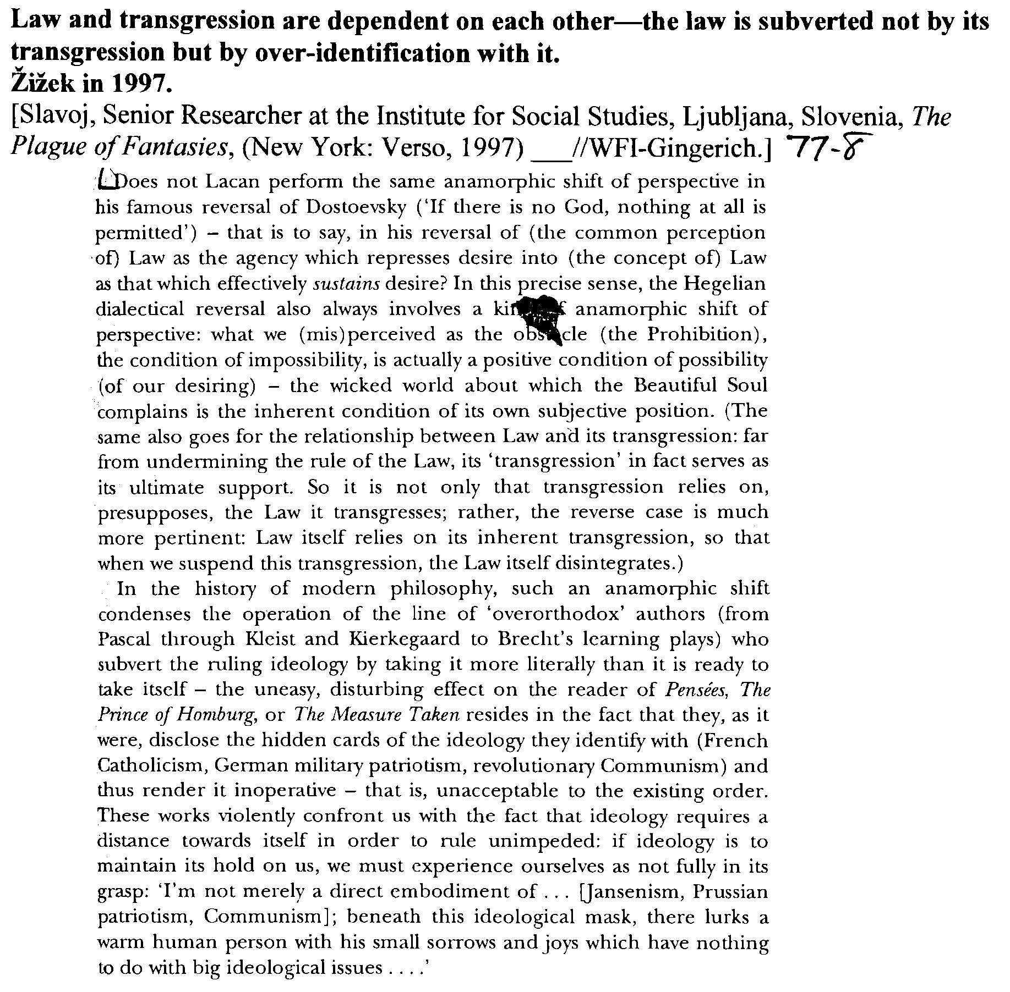
Alternative: Overidentification
Continued…

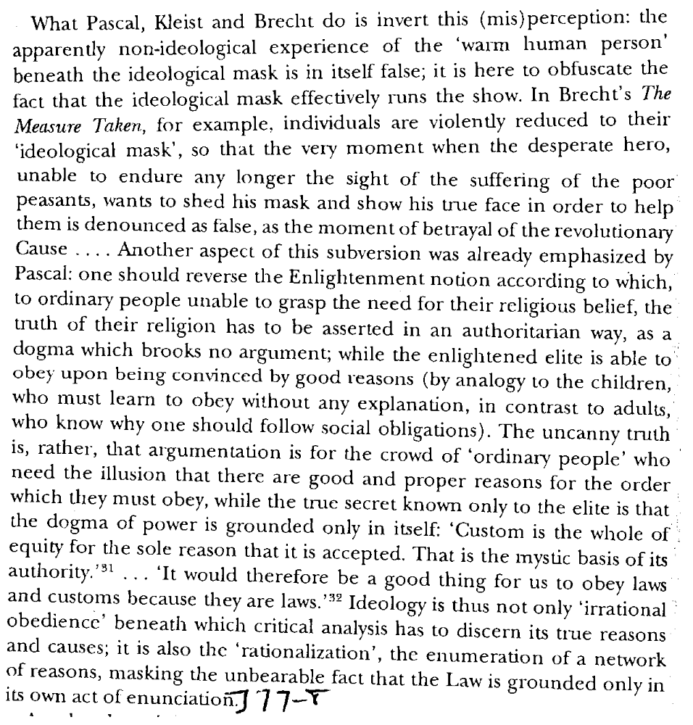
Alternative: Overidentification

Alternative: Overidentification

The best means of undermining racism is by overidentifying with it.
Žižek 1995.
[Slavoj, Philosopher and Psychoanalyst, Institute for Social Studies, University of Ljubljana, “Law and the Postmodern Mind: Superego by Default,” Cardozo Law Review, 16 Cardozo L. Rev. 925, ln//jdg-wfi]
How are we to combat effectively this id-evil which, on account of its "elementary" nature, remains impervious to any rational or even purely rhetorical argumentation? Racism is always grounded in a particular fantasy, which by definition resists universalization. n29 The translation of the racist fantasy into the universal medium of symbolic intersubjectivity (the Habermasian ethics of dialogue) in no way weakens the hold of the racist fantasy upon us. n30 If we are to undermine this power of fantasy, a different political strategy is needed - a strategy able to incorporate what Lacan called "la traversee du fantasme," n31 a strategy of overidentification, which takes into account the fact that the obscene superego qua basis and support of the public law is operative only insofar as it remains unacknowledged, hidden to the public eye. What if, instead of an ironic critical dissection which reveals their impotence before the face of racism's fantasmatic kernel, we proceed a contrario and publicly identify with the obscene superego?

Alternative: Overidentification

In order to function “normally,” the symbolic order cannot be taken literally—to take the symbolic order literally is the best means of disrupting the law.
Žižek 1995.
[Slavoj, Philosopher and Psychoanalyst, Institute for Social Studies, University of Ljubljana, “Law and the Postmodern Mind: Superego by Default,” Cardozo Law Review, 16 Cardozo L. Rev. 925, ln//jdg-wfi]
A commonplace on violence in this postmodern "society of spectacle" is that our perception of reality stems from its media image; reality itself is experienced as an aesthetic spectacle. Outbursts of "irrational" violence are to be grasped against this background; they are desperate attempts to draw a distinction between fiction and reality by way of a passage a l'acte, to dispel the cobweb of the aestheticized pseudoreality and to arrive at the hard, true reality. Far from being simply wrong, this belief is, rather, right for the wrong reasons. What is missing, however, is the crucial distinction between imaginary order and the symbolic fiction. The problem of the contemporary media does not reside in its enticing us to confound fiction with reality, but rather in its "hyperrealist" character, by means of which it saturates the void that occupies the space for symbolic fiction. The symbolic order can only function by maintaining a minimum distance from reality, on account of which it ultimately gains fictional status. Suffice it to recall the anxiety that arises when our words realize themselves "to the letter." In Alfred Hitchcock's Rope, n35 Professor Caddell is unpleasantly surprised when two of his pupils take his theories about the Nietzschean superman's right to murder literally. This surprise bears witness to Caddell's "normality": in order to function normally, the symbolic order cannot be taken literally. When, for example, a waiter greets me with a complimentary "How are you today?" the best way to cause surprise is to take the question seriously and answer it truthfully ("I really had a bad day, a terrible [*939] headache in the morning, etc.") In the "society of spectacle," the overgrowth of imaginary "realistic presentations" leaves open less and less space for this symbolic fiction. What gets lost with media realism, from toys to video, is the experience of "less is more"; when listening to an opera on a compact disk, the very fact that you do not see anything enables you to fill the void with creative fiction. In contrast, there is always something vulgar about an opera on video, due to the very fact that you can see everything and nothing is left to the imagination. What, then, takes place when this imaginary overgrowth saturates the space for symbolic fiction? The void filled out by creative symbolic fiction is the "objet petit a," the object-cause of desire, the empty frame that provides a space for the articulation of desire. n36 When this void is saturated, the distance separating a from reality gets lost and a falls into reality. However, reality itself is constituted by means of the withdrawal of objet a: we can relate to "normal" reality only insofar as jouissance is evacuated from it and the object-cause of desire is missing in it. The necessary consequence of the overproximity of a to reality, which suffocates the activity of symbolic fiction, is therefore a dissolution of reality itself; reality is no longer structured by symbolic fictions, fantasies that regulate the imaginary overgrowth get a direct hold on it. And it is here that violence enters the stage in the guise of the psychotic passage a l'acte. When, hidden behind the curtain, Hamlet the hysteric observes Claudius praying, he cannot decide whether to strike him with the sword; will his killing of Claudius qua flesh and blood deal a blow also to the sublime substance in Claudius, what is "in him more than himself," objet a? n37 Hamlet's doubt enables us to apprehend per negation the psychotic passage a l'acte. In psychosis a is not excluded from reality; it does not function as the void of its formal frame. Consequently, in contrast to the hysteric, the psychotic does not doubt, he knows that a is contained in reality, which is why he can act and actually kill the other, thereby dealing a blow to a. The psychotic passage a l'acte is to be conceived of as a desperate attempt of the subject to evict by force the objet a from reality and thus gain access to reality. (The psychotic "loss of reality" does not arise when something is missing in reality, but rather when there is too much of a thing in reality). This eviction of a also [*940] delineates the matrix of irrational war violence. There, Richard Rorty's reading of George Orwell's 1984 can perhaps be of some help. With respect to Winston's breakdown in the hands of O'Brien, his torturer, Rorty points out that people can experience the ultimate humiliation of saying to themselves, in retrospect, "Now that I have believed or desired this, I can never be what I hoped to be, what I thought I was. The story I have been telling myself about myself ... no longer makes sense. I no longer have a self to make sense of. There is no world in which I can picture myself as living, because there is no vocabulary in which I can tell a coherent story about myself." For Winston the sentence he could not utter sincerely and still be able to put himself back together was "Do it to Julia!" and the worst thing in the world happened to be rats. But presumably each of us stands in the same relations to some sentence, and to some thing. n38 One of the fundamental propositions of Lacanian psychoanalysis is that this sentence or thing which encapsulates the kernel of the subject's being, beyond imaginary identifications, is in an irreducible way decentered with regard to the symbolic texture which defines the subject's identity; the subject can confront this "ex-timate" kernel only at the price of this temporary aphanisis. What Lacan's formula of fantasy - $ - a n39 - designates is the subject's self-erasure in the face of this strange, "ex-timate" body (belief, desire, proposition) which forms the core of his or her being. In other words, aphanisis bears witness to the irreducible discord between the fantasmatic hard core and the texture of symbolic narrative. When I risk confrontation with this hard core, "the story I have been telling myself about myself no longer makes sense," "I no longer have a self to make sense of," or, in Lacanian terms, the big Other (the symbolic order) collapses into the small other, objet petit a - the fantasy-object. n40 The extraction of objet a from the field of reality confers on this field its consistency. In aphanisis, the objet a is no longer extracted, it acquires full presence. In consequence, not only the symbolic texture which constituted my reality [*941] disintegrates, but the very fantasmatic kernel of my enjoyment is laid open and thus comes under attack. n41

AT: “Psychoanalysis Irrelevant to the Law”

Psychoanalysis is of great relevance to the law—not only must law confront the interior of individuals, but the very resentment of the legal profession to psychoanalysis shows the relevance of the pscychoanalytic argument.
Goodrich 1997.
[Peter, Professor of Law, Birkbeck College, University of London, “Maladies of the Legal Soul,” 54 Wash & Lee L. Rev. 1035, ln//jdg-wfi]
Psychoanalytic interpretations of law have not tended to be popular among lawyers or within the conventional parameters of the legal discipline. n10 It is beneficial, therefore, at the outset, to acknowledge and address the resistance or defenses that a psychoanalytic jurisprudence is likely to encounter. Principal among these defenses is the simple argument that psychoanalysis is irrelevant to law. Opponents will claim that psychoanalysis concerns the private and subjective realm of personal relations and individual beliefs. With its emphasis upon dreams, sexuality, symbols, and the unconscious, it belongs - in a sense like morality and religious belief - to a domain anterior to law, a realm of subjectivity or interiority with which secular law is not and never has been concerned. According to this argument, law governs the external acts of a conscious and responsible subject because "the intent of a man cannot be tried, for the devil himself knows not the intent of a man." n11 Although this depiction of law as an objective technology is common both within the profession and in popular perception, claiming that legal governance is exclusively exterior and objective is historically untenable and theoretically absurd. From the time of its discovery, psychoanalysis was something of an heretical enterprise. It threatened the classical order of knowledge and, as a consequence, provoked fear, denial, and ridicule from the established disciplines and their academic watchdogs. In Freud's own analysis, Society did not wish to hear discussion of the discovery of those relationships which psychoanalysis treated, because in many respects it did not have an easy conscience . . . . Psychoanalysis reveals the weaknesses of the [social] system . . . . It argues that it is necessary to abandon the [*1040] rigor of the social repression of instinct and provide a greater place for the truth . . . . For having formulated these critiques psychoanalysis was dubbed the enemy of civilization and was banished as a danger to the public. n12 Freud argued that the social imposition of morality demanded that the individual renounce desire and repress instinct without any substantial recompense from society. Because social institutions and academic disciplines were so badly organized and so ill equipped to deal with the subjective, irrational, or phantasmic dimensions of sociality, it was easy to deny their existence or ridicule their presence rather than to address such aspects of social existence directly or seriously. n13 The same argument applies to law. Psychoanalysis addresses a human subject in his or her corporeal reality as a subject driven by desire. Far from the legal image of a rational and objective actor, psychoanalysis takes apart the mask of reason to reveal a domain of unconscious motives, feelings, and other irrational or more properly subjective biographical sources of action. As Freud well predicted, it is not surprising that law as a discipline and lawyers as a profession would not welcome the intrusion of psychoanalysis into the domain of jurisprudence. The unconscious (what Freud termed "the other scene") is deeply threatening both to the individual and to the institution. The unconscious harbors both the desire and the violence which the Oedipal myth graphically illustrates. It represents that subjective force which neither institutions nor subjects can either fully understand or control. That which the subject does not know but feels, the unwitting dictates of prior experience, lend an ever greater complexity to subjective acts - a complexity which law and lawyers are neither willing nor qualified to judge. Consequently, any attempt to draw out the common terrain of the two disciplines or, more ambitiously, to interpret the unconscious roots of institutional writings and other practices will yield denial, hostility, and polemical rejection. Such resistance or charged discussions of psychoanal-ysis [*1041] and law embody the negative expressions of the truth or, at the very least, indicate the relevance of the psychoanalytic argument.

AT “Lacan’s Formulae are Illogical”

Lacan’s violation of the rules of predicate logic in his formulae of sexuation allows the negation of a portion of a logical formula.
Freiberger 1998.
[Erich, Ph.D., Boston College, “The Cross Dressing of Logic,” Society for Phenomenology and Existential Philosophy, Georgetown University, October 11, 1996, p. 2//jdg-wfi]
I have taken the liberty of rephrasing Lacan’s four formulae into a more standard notation. Thus I have rendered the negations which Lacan portrays with horizontal bars over the quantifiers and the predicates of his formulae as a minus sign, or dash, preceding each part of the formula which Lacan’s horizontal bar negates. I have also enclosed the negated portion of the statement in parentheses, in order better to indicate the way Lacan’s original formulation applies the scope of the negation. The advantage to this approach is that it makes Lacan’s travesty of the syntactical rules of the predicate calculus even more apparent than it might otherwise be. Normally, the rules of syntax demand that any negation standing outside a formula apply to the whole formula. Lacan, however, seems to want to negate each portion of the formula. One can see this clearly in the case of the two feminine formulae” on the right, e.g., (-x)(- ∃x) and (-x) ∃x. But these “formulae” no longer fit within the parameters of the predicate calculus. In fact, they are completely idiosyncratic, because Lacan wants to use the negation as if it only applied to the symbol beneath it, although this clearly violates the established rules of syntax. As Loparic writes, “one symbol of quantification does not constitute a formula all by itself; so, there is no grammatical construction which can put the bar only above this symbol (and not above the rest of the symbols where it appears, and of which it is a part).”

AT: “Lacan Not Scientific”

Lacan’s theory cannot be rejected for lacking an empirical basis or for being entirely relativistic—the law cannot be grounded entirely in postmodernism or in empiricism.
Redding 1996.
[Richard, Instructor in Psych. and Ph.D. candidate, UVA, “Socialization by the Legal System: The Scientific Validity of a Lacanian Socio-Legal Psychoanalysis,” 75 Or. L. Rev. 781, ln//jdg-wfi]
Science is an empirical discipline. Though guided and refined by good theory, science systematically tests hypotheses through controlled, experimental investigation. Lacan's theory may not [*809] be wholly amenable to scientific validation due to its relative lack of specificity. n161 Lacan himself asserted that "he cannot be systematized, [nor] 'understood.'" n162 Piaget long ago observed that Lacan's theory is useless until those "uninitiated" in psychoanalysis can verify his claims. n163 Holland attacks Lacanian theory on the basis that it is not grounded in empirical evidence. n164 However, Lacan was somewhat disdainful of trying to make psychology and psychoanalysis a wholly empirical science. n165 "Science flies on the wings of rhetoric" n166 and it can be argued that empiricism is simply one alternative rhetorical language. n167 This is the postmodern view of science.
In any case, it would be a mistake to ground law or critical legal theory in either extreme of postmodern relativism or objective empiricism. Both scientific structuralism and postmodern relativism can inform our analysis of legal ideology. It is equally mistaken to reject Lacan, claiming either that his theory lacks [*810] any empirical basis or that it is wholly postmodern. Hopefully, I have shown that neither is the case.
Rather, there are significant and complementary points of contact between Lacan and mainstream psychological research and theory. I have outlined the contours of these commonalities. I have also proposed new applications of mainstream psychological theory to Lacanian socio-legal psychoanalysis, and to structuralist and critical-legal approaches generally, including a preliminary model of how socio-legal structure becomes part of the "self." Hopefully, this will focus further attention on socio-legal structures and to the mechanisms that socialize us into them. How does society and its laws become internalized as the "self," and what are the mechanisms of separation and embeddedness between self and the socio-legal system? What are the psychological mechanisms responsible for our reality distortions of the effects of law? For critical legal theorists concerned with the role of legal ideology, and for Lacanian proponents concerned with relationships between the self and society, few undertakings are of greater importance.

AT: “Lacan Not Scientific”

Empirical psychology offers support for many of Lacan’s key arguments and demonstrates that language is at the center of thought and understanding.
Redding 1997.
[Richard, Lecturer in Psychology, University of Virginia; B.A., Hampden-Sydney College; M.S., Vanderbilt University; J.D., Washington and Lee University; Ph.D., University of Virginia, “Book Review: Does Law Need an Analyst?,” 54 Wash & Lee L. Rev. 1119, ln//jdg-wfi]
However, since Lacan's theory (while psychoanalytic) is a theory of human behavior, it is worthwhile to consider what current psychological research actually tells us about the scientificity of Lacanian/postmodern theory. n102 Ironically, despite postmodernists' "attack" on science and scientists' attack on postmodernism, n103 the findings of modern behavioral science appear to support some key tenets of Lacanian/postmodern theory.
Both theoretical and empirical psychology support the position that the development of self implicates the language of otherness, n104 with the onset of language producing a corresponding sense of the self in relation to the Other. n105 Lacan is consistent with modern psychology in arguing that one comes to know the self in the context of knowing others, n106 and interestingly, the sense of self apparently varies somewhat across cultures. n107 Like Caudill, psychologists conceptualize the self as simultaneously embedded in the Other while also unique from the Other. n108
Research also supports the Lacanian/postmodern argument of an important role for language in shaping thought and knowledge - even scientific research. Science is entangled in language, and it has been noted that labels used in research reflect implicit ideologies that constrain research questions. n109 More generally, research clearly shows that language affects choices and decision making. n110 Research also suggests that the particular language we speak affects our thinking and social behavior - for example, how we classify things, what we remember, n111 and the structure of our social interactions. n112 At least in some domains, thought comes into existence through language; n113 the degree to which language shapes, or is necessary for thought, is highly debated in psychology, though.

AT: “Lacan Not Scientific”

Empirical research demonstrates that it is impossible to escape ideology.
Redding 1997.
[Richard, Lecturer in Psychology, University of Virginia; B.A., Hampden-Sydney College; M.S., Vanderbilt University; J.D., Washington and Lee University; Ph.D., University of Virginia, “Book Review: Does Law Need an Analyst?,” 54 Wash & Lee L. Rev. 1119, ln//jdg-wfi]
Further, research supports the postmodern/Lacanian view that no one, not even judges or scientists, can escape ideology. A large body of research has demonstrated people's tendency to evaluate information in a manner consistent with their own biases and prior beliefs. n114 For instance, one study presented synopses of studies on the deterrence effect of capital punishment to psychology majors, and asked them to rate each study's persuasiveness and methodological soundness. Those favoring capital punishment rated higher the study finding a deterrence effect, whereas those against capital punishment rated higher the study finding no deterrence effect. n115 Another study showed a socio-political bias effect among judges and law students in how they evaluated social science research evidence. n116 Similarly, scientists' judgments about the methodological soundness and publishability of research studies varies significantly according to whether the research matches their theoretical orientation. n117 Scientists also tend to overlook obvious and serious methodological flaws in research studies where they perceive the topic of the study to be important, but they generally detect those flaws in research they consider less important. n118
Importantly, the biasing effects of ideology cannot be escaped because bias often is located in the unconscious. As empirical studies have shown, unconscious biases affect our conscious judgments. n119 Using a technique called semantic priming, these studies used computer screens to flash words at participants at speeds so fast that they were consciously unaware of their content. In one study, the semantic priming consisted of pairing nonsense words with other words having either negative, positive, or neutral connotations. Afterwards, participants were presented, at the level of conscious awareness, each nonsense word and asked to rate its pleasantness. Participants rated the nonsense words as more pleasant when the word had been paired with a pleasant word in the semantic priming phase. n120 In another study, participants were primed with words representing either neutral or negative stereotypes of African- Americans. They then read a paragraph describing an African-American in ambiguous terms and rated the individual described. Those primed with the negative stereotypes rated the character more negatively. n121

AT “Sexual Difference Can be Avoided”

The assumption of either a masculine or a feminine symbolic position is fundamental to the construction of subjectivity.
Evans 1996.
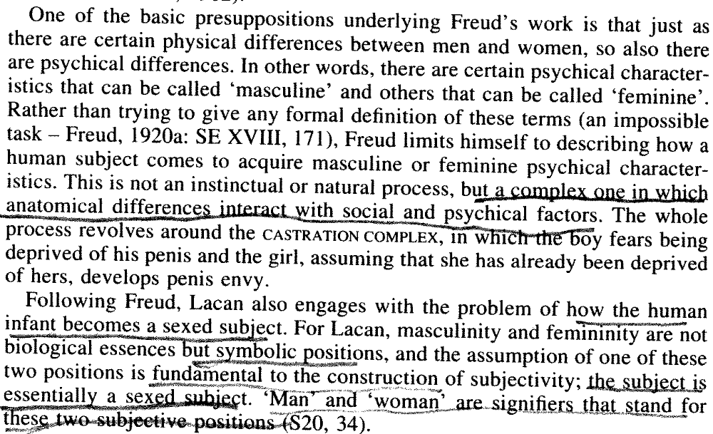
[Dylan, An Introductory Dictionary of Lacanian Psychoanalysis (London: Routledge) 178//jdg-wfi]

AT “Lacan is Bioessentialistic”

There is a rupture between the biological aspect of sexual difference and the unconscious. Thus, there is no signifier of sexual difference in the symbolic order.
Evans 1996.
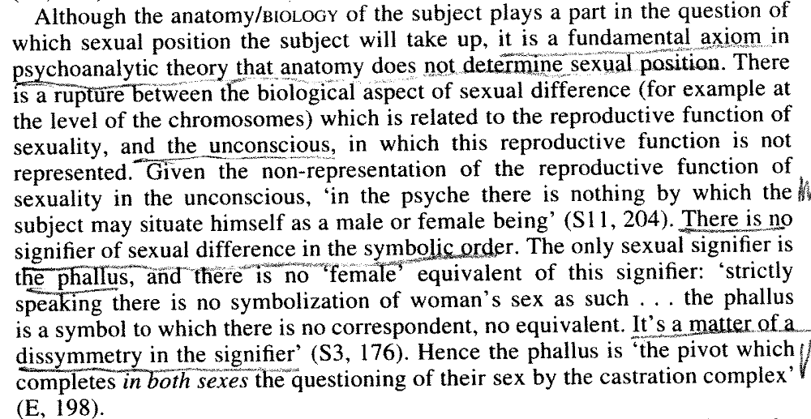
[Dylan, An Introductory Dictionary of Lacanian Psychoanalysis (London: Routledge) 179//jdg-wfi]

AT: Feminism

The feminist move to support a notion of feminine generativity as participation in a primordial fullness beyond the phallic order actually fails to acknowledge feminine jouissance. Feminine jouissance cannot serve as a positive basis for social change. Psychoanalysis is the hystericizing discourse that recognizes feminine jouissance.
Freiberger 1998.
[Erich, Ph.D., Boston College, “The Cross Dressing of Logic,” Society for Phenomenology and Existential Philosophy, Georgetown University, October 11, 1996, p. 10-11//jdg-wfi]

On this view, those feminists who read Lacan’s notion of feminine jouissance politically, or who support some notion of feminine generativity as participating in some primordial fullness beyond the phallic order, are subject to the same meconnaissance as phallocentrism, for like the metaphysical tradition, they too fail to grasp Lacan’s articulation of the meaning of feminine jouissance as a jouissance of the lack imposed by the law. This lack is nothing positive; rather, it is simply the lack constituted by our subjection to castration, understood as both the symbolic lack of the signifier and the real lack of our subjection to sexuation and death. Thus,feminine jouissance is not an enjoyment of an imagined lack of subjection to the law, but rather an enjoyment and an implicit recognition of our subjection to the lack in the Other. As such, it is more an insight into the limits of the phallic law, and an integrated acceptance of the absolute limitation constituted by the lack which the phallic law conceals, than it is something which can be reified and thus brought into the phallic order as something positive, upon which either feminist or church fathers, for that matter, might establish a platform for social change. This is why Lacan can say that most women do not even know anything about it. Their lack of awareness of it indicates the contingent and ephemeral character of this jouissance. By positing the ek-sistence, or standing forth, of feminine jouissance beyond the phallic order Lacan is in effect claiming that the hysterizing discourse of psychoanalytic theory can name feminine jouissance because it itself emerges out of such a jouissance of the lack by which the subject is constituted.

AT: Feminism

Feminism that seeks to define feminine experience as outside of the phallic law fails to move past the ideology of the Moral Majority and remains trapped in the phallic order.
Salecl 1995.
[Renata, philosopher and sociologist, working as a researcher at the Institute of Criminology, Faculty of Law, University of Ljubljana, “Law and the Postmodern Mind: Rights in the Psychoanalytic and Feminist Perspective,” Cardozo Law Review, 16 Cardozo L. Rev. 1121, ln//jc-wfi]
Feminist legal theory locates the main reason for the patriarchal character of human rights in the theoretical premises of liberalism. In particular, Robin West's reproach to modern American legal theorists insists that all of them, regardless of their liberal or critical (Marxist) backgrounds, explicitly or implicitly embrace the "separation thesis" about what it means to be a "human being." The "separation thesis" claims that the "distinction between you and me is central to the meaning of the phrase "human being' " and that individuals are " "distinct and not essentially connected with one another.' " n14 Problematically, separation is perceived not only as physical separation, but also as an epistemological and moral precondition of any possible cooperation between human beings; such separation is also held to be necessary for the origin of law. West rejects this position because, in her opinion, the "separation thesis" may be "trivially true" for men, but is patently untrue of women:

Women are not essentially, necessarily, inevitably, invariably, always, and forever separate from other human beings: women, distinctively, are quite clearly "connected" to another human life when pregnant... Indeed, perhaps the central insight of feminist theory of the last decade has been that women are "essentially connected," not "essentially separate," from the rest of human life, both materially, through pregnancy, intercourse, and breast-feeding, and existentially, through the moral and practical life. If by "human beings" legal theorists mean women as well as men, then the "separation thesis" is clearly false. If, alternatively, by "human beings" they mean those for whom the separation thesis is true, then women are not human beings. It's not hard to guess which is meant... n15

[*1128] What strikes us in this argument is that it could just as easily be promoted by advocates of the Moral Majority. The ideology of the Moral Majority, in another context, says the same thing: women are essentially linked to children and because of this are more "warm and compassionate." The Moral Majority would also agree that people today are too separated from one another and that we need to return to some kind of "real connection." However, while such advocates would argue against "separation" in order to impose the view that the place of women is at home (where a woman can always be "connected" with her husband and children and thus find the expression of her true "essence"), West's intention is, on the contrary, to find ways to overcome patriarchal domination.

AT: Feminism

The Cartesian cogito provides the possibility of resistance to patriarchy and it not itself essentially patriarchal.
Salecl 1995.
[Renata, philosopher and sociologist, working as a researcher at the Institute of Criminology, Faculty of Law, University of Ljubljana, “Law and the Postmodern Mind: Rights in the Psychoanalytic and Feminist Perspective,” Cardozo Law Review, 16 Cardozo L. Rev. 1121, ln//jc-wfi]
If Descartes still thought of the cogito as a "thinking thing," with Kant the cogito became the locus of a nonsubstantial subjectivity. In Kant's view, the cogito, as the empty form of apperception, does not have any positive ontological consistency in itself. As such, the cogito is neither male nor female: thus, we cannot say [*1130] that it is essentially patriarchal. On the contrary, it is the very nonsubstantiality of the cogito, its abstract character, which enables us to discern features of patriarchal domination.
Lacan, who has been cited as one of the last "Cartesian orphans," n19 discovered this Kantian potential in the notion of the cogito. First of all, Lacan radically "desubstantializes" the cogito by showing how Descartes's reading of the cogito as res cogitans reveals that Descartes misunderstood his own invention. Cogito is definitely not "a thing which thinks," instead it is a thoroughly empty form, a substanceless point of self-reflection. And Lacan's wager is that, on the ground of this substanceless void of the cogito, it is possible to formulate sexual difference. Here we have to take into account Lacan's seemingly paradoxical assertion that the subject of psychoanalysis is none other than the Cartesian subject of modern science. This subject emerges by way of the radical desexualization of the human relationship to the universe. That is to say, traditional Wisdom was thoroughly anthropomorphic and "sexualized" its comprehension of the universe structured by oppositions bearing an indelible sexual stamp: yin-yang, light-darkness, active-passive. On this anthropomorphic model, the relation between the microcosm and the macrocosm, between the parallel structures of human beings, society and universe, was perceived in terms of both correspondence and organic unity. For example, the birth of the universe was derived from the coupling of the Earth and the Sun; society was regarded as a body politic with the monarch as its head and workers as its hands. In modern society, in contrast, we are confronted with a nonanthropomorphic reality perceived as a blind mechanism which "speaks the language of mathematics" and can be expressed only through inherently meaningless formulas. In this society, every search for a "deeper meaning" of phenomena inevitably fails. The modern subject thus emerges without any support in the universe and searches in vain for traces of its meaning. The pain of adapting to such a reality is evident from the recent return of an anthropomorphic-sexualized worldview in the guise of pseudo-ecological Wisdom ("new holism," "new life paradigm," etc.).

AT: Feminism

Abandoning the Kantian cogito would not allow for a displacement of patriarchy but instead to worse patriarchy.
Salecl 1995.
[Renata, philosopher and sociologist, working as a researcher at the Institute of Criminology, Faculty of Law, University of Ljubljana, “Law and the Postmodern Mind: Rights in the Psychoanalytic and Feminist Perspective,” Cardozo Law Review, 16 Cardozo L. Rev. 1121, ln//jdg-wfi]
We must also abandon the idea that before modern society (established on the notion of the Kantian cogito) there existed a society where patriarchal domination did not exist in a form as explicit as it is now. In pre-Cartesian society sexual difference as such did not exist; society was organized as a sexual community per se and functioned as an extended family. This society was a hierarchic organization: people were born into their social roles (of rich or poor, and of women or men). Patriarchal domination was therefore universal, spread throughout the whole of society. When, with the advent of modernity, society became an organization of autonomous individuals and previous sexual communities were replaced by national communities, patriarchy had to affirm itself in an implicit masked way. Only when people were perceived as formally equal did sexual difference as such become thinkable. With this claim, I do not intend to contradict the feminist thesis that philosophy is marked by patriarchal ideology. n22 My point is simply that the foundation of this ideology is not the cogito as feminists currently perceive it, and on the contrary, that the very notion of the cogito can provide ways to overcome patriarchy. [*1132]

AT: “Together the Sexes Form a Whole”

Lacan’s theory of masculine and feminine incompletion gives merit to the fact that the two imperfect beings do not together form a whole.
Salecl 1995.
[Renata, philosopher and sociologist, working as a researcher at the Institute of Criminology, Faculty of Law, University of Ljubljana, “Law and the Postmodern Mind: Rights in the Psychoanalytic and Feminist Perspective,” Cardozo Law Review, 16 Cardozo L. Rev. 1121, ln//jc-wfi]
It is against this background that we can measure the extent of Lacan's achievement: he was the first to outline the contours of a nonimaginary, nonnaturalized theory of sexual difference, a theory which radically breaks with anthropomorphic sexualization [*1131] ("male" and "female" as the two cosmic principles, etc.). For Lacan, "the formulation of sexual difference and sexual desire are not tied to any essential body." n20 This is why drawing a parallel between Lacan's "formulas of sexuation" and Kant's antinomies of pure reason is fully justified: in Lacan, "masculine" or "feminine" is not a predicate that provides positive information about the subject or designates some of its phenomenal properties; "masculine" or "feminine" is rather a case of what Kant conceives of as a purely negative determination, one which merely marks a certain limit. More precisely, such a negative determination registers a specific modality of how the subject failed in its bid for an identity which would constitute it as an object within phenomenal reality. n21 Lacan is thus as far as possible from the notion of sexual difference as the relationship of two opposite poles which complement each other, together forming a whole of Man: "masculine" and "feminine" are not the two species of the genus of Man, but rather, the two modes of the subject's failure to achieve the full identity of Man. "Man" and "Woman" together do not form a Whole, since each of them is already in itself a failed Whole.

AT Intersubjectivity

The Kantian subject as an empty form of apperception is necessary for the conception of intersubjectivity.
Salecl 1995.
[Renata, philosopher and sociologist, working as a researcher at the Institute of Criminology, Faculty of Law, University of Ljubljana, “Law and the Postmodern Mind: Rights in the Psychoanalytic and Feminist Perspective,” Cardozo Law Review, 16 Cardozo L. Rev. 1121, ln//jdg-wfi]
It is possible to answer Robin West's criticism of liberal theory, as a theory that wrongly defines the subject as separated from other subjects, on two levels. First, psychoanalytic as well as Foucauldian and deconstructionist feminist theory have for decades strongly opposed the view of the subject held by West. When she speaks about women as connected, West implicitly views the subject in a biologically determined and fixed way. The contribution of modern feminist theory is not, as West says, the view that "women are essentially connected" with other human beings, but rather, what feminist theory does is to analyze the effects of the patriarchal ideology which perceives of women as connected, warm, etc. Second, in opposing the liberal "separation thesis," feminist theory does not recognize that it is the Kantian subject (on which liberal theory is grounded) which makes it possible for feminist theorists to think of intersubjectivity. The Kantian subject, as an empty form of apperception, is always in need of another subject to ground its identity: as long as I am an empty, split subject, what I am is always linked to what the Other (in the sense of another human being, as well as the symbolic order) thinks I am. n23

AT: CLS

Critical legal studies theorists fail because their rejection of abstract human rights simply replaces the present legal system with the pretension that particular principles are pure justice while destroying the possibility of democracy.
Salecl 1995.
[Renata, philosopher and sociologist, working as a researcher at the Institute of Criminology, Faculty of Law, University of Ljubljana, “Law and the Postmodern Mind: Rights in the Psychoanalytic and Feminist Perspective,” Cardozo Law Review, 16 Cardozo L. Rev. 1121, ln//jdg-wfi]
One can respond in the same way to the thesis of Critical Legal Studies ("CLS"), according to which the advocacy of abstract human rights does not help change concrete relations of domination in society or reduce the gap between rich and poor. n8 CLS the- [*1125] orists do not recognize that it was only by virtue of the notion of abstract human rights that people first acquired the means to assess social injustice: this abstract idea first enabled people to articulate social differences in the language of law. When CLS theorists argue that society is in principle unjust and that we have to change it - instead of simply legitimating the state by speaking about human rights - they fall into the same trap into which the advocates of Communism have fallen. Communist legal theorists argue that their Communist system is in principle the most just system in the world - thus they do not need the bourgeois idea of human rights, all they have to do is to realize Communist ideals in everyday life. n9 Thus CLS theorists and the Communists say the same thing in different words: we have to counter abstraction by fighting for concrete changes, or in a vulgar jargon - we have to get to work [*1126] instead of theorizing. But both theories, by rejecting the abstract idea of human rights, negate the inner logic of democracy. Thus Lefort argues that, modern democracy is founded upon,

the legitimacy of a debate as to what is legitimate and what is illegitimate - a debate which is necessarily without any guarantor and without any end. The inspiration behind both the rights of man and the spread of rights in our day bears witness to that debate.
...
The singular thing about the freedoms proclaimed at the end of the eighteenth century is that they are in effect indissociable from the birth of the democratic debate. Indeed, they generate it. We therefore have to accept that whenever these freedoms are undermined, the entire democratic edifice is threatened with collapse, and that, where they do not exist, we look in vain for the slightest trace of it. n10

AT Capitalism is Psychotic (D&G)

Capitalism is not psychotic—modernity is not delusional.
Salecl 2005.
[Renata, Senior Researcher at Institute of Criminology, Faculty of Law, University of Ljubljana, Slovenia, “WALTER BENJAMIN AFTER THE 20TH CENTURY: THE FUTURE OF A PAST: WORRIES IN A LIMITLESS WORLD,” Cardozo Law Review, 26 Cardozo L. Rev. 1139, February 2005, ln//lh-jdg]
But are they the only authorities; is the world really that different from the past? Are we really living in a limitless world? We have increasingly interventionist states, and authoritarian leaning leaders like Bush and Blair, and numerous other authorities in the form of self-help gurus, religious leaders, and the like. Given that this is the case, then why does the ideology of the late capitalist self encourage us to live "as if" we were without limits, in fact free? Is the modern self out of touch with reality, delusional in some sense? Can we argue that late capitalism is producing more psychosis, as some psychoanalysts want to suggest?
This would be a duly simplistic and pessimistic conclusion. There is certainly some evidence for increasing plasticity in forms of identification. Players on the internet rarely appear as themselves, preferring in many cases to change not only their gender and sexual orientation, but also their race, religion, and age. There is nothing new about fantasizing about being someone else, but modern trends suggest something more profound. In the 18-25 year-old age group in the U.K., more young people not only report having had a sexual experience with both a person of the same sex and of the opposite sex, but they are unwilling to classify or categorize their sexuality on the basis of sexual practice. The distinction gay/straight appears to have little purchase for [*1153] these young people in terms of how they categories themselves and others. As one commentator remarked "Homosexuality is over!" n24
However, refusing categorization and playing with your sexual identity is not the same thing in any sense as Schreber's delusion that he had been turned into a woman. Schreber had no doubt about his bodily transformation. It is also not the same thing as the mimicry in the case of "the successful patient" described earlier whose transformations caused him no anxiety or uncertainty. In contrast, those of us who are ceaselessly remaking ourselves in the contemporary moment have many doubts, and can often feel overwhelmed by the fear of failure. Our play with identifications is quite different from the mimicry of the psychotic. His or her certitude is replaced in the contemporary moment with something that looks more like the celebration of undecidability.
Yet, this undecidablity is itself caught up in capitalist circuits as evidenced by the rise - and subsequent marketing - of the metrosexual. Metrosexuality, rather than being a sexual identity, is more a set of consumer identifications. So under late capitalism, shifts in identity and indeed in identifications are celebrated as the new vogue and turned into profit.
But, despite this process, there is little proof that contemporary society is increasingly psychotic. People are still deeply concerned with the question of who they are for others, and how they should interact with others. One reason, perhaps, why we are seeing an increasing obsession with self-help books. We certainly live in a world that is self-centered and encourages us to "love ourselves." However, to follow this imperative is not a simple matter, which is why finding an answer to it is a lucrative business. A simple search on amazon.com tells us that there are 138,987 books which try to help you love yourself. Including one with the title the Learning to Love Yourself Workbook, which shows that labor is as important a part of capitalism as ever.

AT Queer Theory

The attempt to create more sexual freedom only inscribes new prohibitions on the subject.
Salecl 2005.
[Renata, Senior Researcher at Institute of Criminology, Faculty of Law, University of Ljubljana, Slovenia, “WALTER BENJAMIN AFTER THE 20TH CENTURY: THE FUTURE OF A PAST: WORRIES IN A LIMITLESS WORLD,” Cardozo Law Review, 26 Cardozo L. Rev. 1139, February 2005, ln//lh-jdg]
Let us look at how the lack of limits affects personal relationships today? In a society determined by the idea of choice matters of love and sexuality at first seem extremely liberating. What is better than envisioning the possibility to be free from social prohibitions when it comes to our sexual enjoyment; how wonderful it appears to finally stop bothering about what parents and society at large fashion as normal sexual relations; and how liberating it seems to change our sexual orientation or even physical appearance of sexual difference. It is more than obvious that such "freedom" does not bring satisfaction; on the contrary, it actually limits it.
In analyzing human desire, psychoanalysis has from the beginning linked desire with prohibition. For the subject to develop desire,something has to be off limits. When the subject struggles with ever evolving dissatisfaction in regard to the non-attainability of his or her object of desire, the solution is not to get rid of the limit in order to finally fuse with the object of desire, but to be able to somehow "cherish" the very limit and perceive the object of desire as worthy of our striving precisely because it is inaccessible.
Looking at today's media talk about sexuality, it is not difficult to observe that there are very few things that are prohibited (with the exception of child molestation, incest, and sexual abuse), while there is an overwhelming "push to enjoy." Sexual transgression is marketed as [*1155] the ultimate form of enjoyment. The idea being that if one works on it, learns its tricks and then practices it relentlessly, there are no limits to the satisfaction a person can achieve. Cosmopolitan magazine thus encourages those who have not yet mastered new techniques of reaching ultimate joys to enroll in sex school. Simultaneously with this marketing of enjoyment, one reads in the popular media about the very impossibility to enjoy. John Gray, the famous author of Men Are From Mars, Women Are From Venus now writes about "Why my grandmother seems to have more sex than I do." n28 His answer, of course, again turns into another form of advice: be more relaxed, follow these or that steps of arousing desire, etc.
When we look at how we deal with sexuality in this supposedly limitless society, it is easy to observe that limits did not actually disappear or that prohibitions still exist; however, the locus from where they came has changed. If, in the past, prohibitions have been transmitted with the help of social rituals (like initiation rituals in pre-modern society, and functioning of the "Name-of-the-Father" in the traditional patriarchal society), today the subject sets his or her own limits. The contemporary subject is thus not only self-creator, but also his or her own "prohibitor."

AT: “Lacan is Incomprehensible”

Despite the opacity of Lacan’s writings, Lacanian theory is of great relevance to legal studies.
Redding 1997.
[Richard, Lecturer in Psychology, University of Virginia; B.A., Hampden-Sydney College; M.S., Vanderbilt University; J.D., Washington and Lee University; Ph.D., University of Virginia, “Book Review: Does Law Need an Analyst?,” 54 Wash & Lee L. Rev. 1119, ln//jdg-wfi]
The opaque quality of Lacan's writings creates three major problems. First, and most important, it leaves him open to the criticism that the complexity obscures an infinitely malleable or even vacuous content n21 - in effect, that "the emperor has no clothes." n22 Second, it makes it difficult to evaluate scientifically Lacan's notions about human behavior because they are not always reducible to empirical constructs. Third, it makes it difficult to apply the theory to law. If Lacanian scholars have a hard time understanding the theory, what hope is there for legal practitioners?
Caudill's book positively inclines the reader towards Lacan, notwithstanding all the barriers to understanding and applying the theory. Lacan's undue complexity is a serious obstacle to his use in law, but Caudill does a wonderful job of explaining Lacan's theory in clear terms, perhaps as clearly as it can be explained. Caudill explicates how the theory can be applied to law in practical terms, and herein lies one of the book's key contributions. Caudill demonstrates to critics that the emperor does have clothes.

FYI—Formulae

An explanation of Lacan’s formulae of sexuation.
Freiberger 1998.
[Erich, Ph.D., Boston College, “The Cross Dressing of Logic,” Society for Phenomenology and Existential Philosophy, Georgetown University, October 11, 1996, p. 1-2//jdg-wfi]

Lacan’s account of sexual difference in his Seminar XX, Encore, has become something of a commonplace in recent work on sex and gender in a wide array of fields in the Humanities from philosophy and feminism to cultural studies and queer theory. It is often cited and hotly debated, but it has rarely been approached through a direct examination of the logical formulae in which he articulates his theory. In what follows I explain Lacan’s account of sexuation by showing how it distorts the formulae of the predicate calculus to achieve a precise effect. In contast with the few commentators who attempt to explain Lacan’s position, I argue that Lacan’s appeal to logic can be made sense of in its own terms. Rather than introducing some new or alternative logic, I demonstrate that Lacan is consciously distorting and mimicking the structure of the Predicate calculus in an attempt to suggest what it fails to comprehend. After a brief review of what these formulae mean in their original context, I show how Lacan subverts their original sense in a manner that suggests that the goal of analysis is a feminine jouissance, understood as a jouissance that is attained by inverting the lack in the Other back into the body. I conclude with a short explanation of Lacan’s claim that metaphysics has systematically misunderstood feminine jouissance as the jouissance of God.

Diagram A:Translation & Definition of the Four Formulae of Sexuation

Paternal function Feminine Jouissance

1. ∃x(-Φx) 3. (-∃x)(-Φx)
There is one not subject to Φx Not one is not subject to Φx

Man Woman
2. ∀x Φx 4. (- ∀x) Φx
All are subject to Φx Not all are subject to Φx

The reversed E and the inverted A are called existential and universal quantifiers, and they are employed in the predicate calculus to define the scope of predication in a given propositional statement. In such statements some subject ‘x’, is asserted to possess a specific predicate (in Lacan’s usage this is the predicate of being subject to the phallic function). But as one can see, the subject ‘x’ appears twice. First as quantified (to indicate the possible range of values x might possess) and then again to indicate its attachment to a predicate.
Let us consider an example: ∃x Fx. One reads this as “there is at least one x such that x has the attribute F.” In other words, the meaning of x, specifies a certain quantified range of individuals (in this case “at least one” rather than “all”) which is subject to the predicate-function F. Thus we can already see that Lacan’s usage of this argument function schema primarily means that, the quantified range of individuals in x is subject to the functionΦ. Hence, within “the universe of discourse” of speaking beings (which is the range of possible values for x), some quantified class of individuals ( ‘at least one’ or ‘all’) is or is not subject to the function Φ, the phallic function. In other words, some quantified class of individuals is or is not subject to the function of castration.

FYI—Formulae

Lacan’s formulae of sexuation. (FYI)
Freiberger 1998.
[Erich, Ph.D., Boston College, “The Cross Dressing of Logic,” Society for Phenomenology and Existential Philosophy, Georgetown University, October 11, 1996, p. 5//jdg-wfi]

Figure B: Lacan’s attempt to suggest feminine jouissance through the evagination of (-∃x)(-Φx)
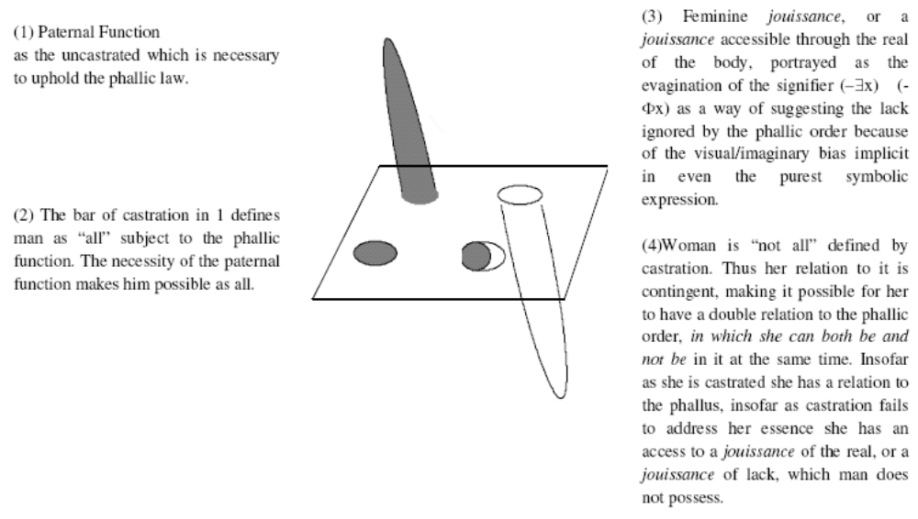

FYI—Diagram

Woman relates to the phallic order both phallicly and non-phallicly.
Freiberger 1998.
[Erich, Ph.D., Boston College, “The Cross Dressing of Logic,” Society for Phenomenology and Existential Philosophy, Georgetown University, October 11, 1996, p. 8//jdg-wfi]
Diagram C: Woman’s Dual Relation to the Phallic Order

S S (Ø)

a

The

Φ

Drug Use Impact Module

The will to phallic jouissance leads to social hate and drug use.
Salecl 2005.
[Renata, Senior Researcher at Institute of Criminology, Faculty of Law, University of Ljubljana, Slovenia, “WALTER BENJAMIN AFTER THE 20TH CENTURY: THE FUTURE OF A PAST: WORRIES IN A LIMITLESS WORLD,” Cardozo Law Review, 26 Cardozo L. Rev. 1139, February 2005, ln//lh-jdg]
When the subject deals with castration, he or she deals also with dissatisfaction. However, today, what we are observing is an increase in frustration and not so much an escalation of dissatisfaction. Frustration is, in a special way, linked to a subject's problem with jouissance. Jean-Pierre Lebrun thinks that "when will to jouissance dominates the social field, brotherly solidarity of proletarians is replaced by competition and competitive rivalry. Which is where emerges exacerbation of social hate." n31 In contemporary racism, for example, the subject presupposes that the Other has access to some full jouissance which provokes frustration on the side of the subject. In personal relationships, the problem is that the subject tries to get some excess enjoyment from the partner (for men, a sexual one, for women, a narcissistic one) and after this attempt necessarily fails, the partner loses [*1157] importance and becomes one of the objects one can easily reject. For the subject who lacks stable identifications, has a fluctuating choice of objects, instability in affective investments, and quickly passes to act, one way to try to find the lost jouissance is with the help of addictive substances. Which is why there is an increase in addictive behavior today.

Addictive drug use fuels international terrorism.
Ottawa Citizen 2004.
[Drew Johnson-Skinner, staff, July 5, ln//jdg-wfi]
Particularly worrisome is Charles's description of drug and terror connections in North America. He points to Mexico as a "major source of methamphetamine, black tar heroin and marijuana consumed in the United States" and linked to a California-based terror-financing operation that was busted in 2002. Two Pakistanis and one American were arrested in California for trying to provide al-Qaeda with Stinger missiles in a missiles-for-drugs exchange.
Charles quotes a California Department of Justice report as finding that the money from the California drug cells was sent to "Yemen, Israel, Brazil, and Jordan -- countries that have been infiltrated by terrorist organizations such as ... Hamas, Hezbollah and al-Qaeda."
Charles also writes of "the American addiction" to narcotics. He fingers American and European buyers for providing the money that flows to terrorists. Responsibly, Charles also points out the "medical, economic, political, and cultural effects" of drug-use problems in addition to its funding terrorism. Charles also gives good news about American narcotics use -- he credits drug education and confiscation programs as leading to a decrease in narcotics use at home. "Narcotics dependency -- for an individual or a society -- can be reduced," he writes.

Drug Use Impact Module

Terrorism risks extinction.
Alexander 2003.
[Yonah, professor and director, Inter-University for Terrorism Studies, August 23, Jerusalem Post, ln//jdg-wfi]

Last week's brutal suicide bombings in Baghdad and Jerusalem have once again illustrated dramatically the international community's failure, thus far at least, to understand the magnitude and implications of the terrorist threat to the survival of civilization itself. Even the United States and Israel have for decades tended to regard terrorism as a mere tactical nuisance or irritant rather than as a critical strategic challenge to their national security concerns. It is not surprising, therefore, that on September 11, 2001, Americans were stunned to witness the unprecedented tragedy of 19 al-Qaida terrorists striking a devastating blow at the center of the nation's commercial and military centers. Likewise Israel and its citizens, despite the collapse of the Oslo Accords of 1993 and numerous acts of terrorism triggered by the second intifada that began almost three years ago, are still "shocked" by each suicide attack. Why are the US and Israel, as well as scores of other countries affected by the universal nightmare of modern terrorism, continually shocked by terrorist surprises? There are several reasons: * A misunderstanding of the manifold factors contributing to the expansion of terrorism, such as the absence of a universal definition of terrorism; * The religionization of politics; * Double standards of morality, weak punishment of terrorists, and exploitation of the media by terrorist propaganda and psychological warfare. Unlike their historical counterparts, contemporary terrorists have introduced a new scale of violence in terms of conventional and unconventional threats and impact. The internationalization and brutalization of current and future terrorism make it clear that we have entered an Age of Super-Terrorism - biological, chemical, radiological, nuclear, and cyber - with its serious implications for national, regional, and global security concerns. Two myths in particular must be debunked immediately if an effective counterterrorism strategy can be developed; for example, strengthening international cooperation. THE FIRST illusion is that terrorism can be greatly reduced, if not eliminated completely, provided the root causes of conflicts - political, social, and economic - are addressed. The conventional illusion is that terrorism used by "oppressed" people seeking to achieve their goals is justified. Consequently, the argument advanced by so-called freedom fighters - "give me liberty and I will give you death" - is tolerated, if not glorified. This traditional rationalization of "sacred" violence often conceals the fact that the real purpose of terrorist groups is to gain political power through the barrel of the gun, in violation of fundamental human rights of the noncombatant segment of societies. For instance, Palestinian religious movements, such as Hamas and Islamic Jihad, and secular entities, such as Fatah's Tanzim and the Aksa Martyrs Brigade, wish not only to resolve national grievances such as settlements, the right of return, and Jerusalem, but primarily to destroy the Jewish state. Similarly, Osama bin Laden's international network not only opposes the presence of American military in the Arabian Peninsula and Iraq; its stated objective is to "unite all Muslims and establish a government that follows the rule of the Caliphs." The second myth is that initiating strong action against the terrorist infrastructure - leaders, recruitment, funding, propaganda, training, weapons, operational command and control - will only increase terrorism. The argument here is that law enforcement efforts and military retaliation will inevitably fuel more brutal revenge acts of violence. Clearly, if this perception continues to prevail, particularly in democratic societies, the danger is that such thinking will paralyze governments into inaction, thereby encouraging further terrorist attacks. Past experience provides useful lessons for a realistic strategy. The prudent application of force has demonstrated that it is an effective tool in deterring terrorism in the short and long terms. For example, Israel's targeted killing of Mohammed Sider, the Hebron commander of the Islamic Jihad, defused a ticking bomb. The assassination of Ismail Abu Shanab, a top Hamas leader in the Gaza Strip, directly responsible for several suicide bombings including the latest bus attack in Jerusalem, disrupted potential terrorist operations. Similarly, the US military operation in Iraq eliminated Saddam Hussein's regime as a state sponsor of terror. Thus it behooves those countries victimized by terrorism to understand a cardinal message communicated by Sir Winston Churchill to the House of Commons on May 13, 1940: "Victory at all costs, victory in spite of terror, victory however long and hard the road may be: For without victory there is no survival."

Drug Use Impact Module

HIV spread by IV drug use in Eastern Europe will destroy democracy in Eastern Europe and collapse the economy.
San Francisco Chronicle 2002.
[Sabin Russell, Chronicle Medical Writer, July 11, ln//jdg-wfi]
From the jungles of southeast Asia to the streets of Moscow, the AIDS virus is riding on the back of a global heroin epidemic and taking root among the most populous nations on Earth. The link between HIV infection and injection drug use was one of the earliest discoveries of the epidemic. But it is only recently that disease trackers have detected signs of a rapidly spreading drug-related outbreak in Eastern Europe and Asia that is also threatening to reach into the general population. "Central Asia is a bomb waiting to explode," said Kasia Malinowska-Sempruch, a native of Poland who directs a drug-related AIDS program for the Open Society Institute. Financed by maverick philanthropist George Soros, the Open Society Institute urges that the world adopt successful "harm reduction" tactics such as needle exchange programs that are credited with rolling back an outbreak of HIV among drug users in San Francisco. The highest increases in the rate of HIV infections are in the former Soviet Union. As many as 840,000 Russians are estimated to be infected with the AIDS virus, the great majority of them drug-related cases. A quarter-million Ukrainians, or 1 percent of the population, are HIV-positive, the highest infection rate in Europe. Three out of 4 infections are among drug users or their sexual partners, and ominously, rates of pregnant women with HIV are rising -- suggesting a shift toward a heterosexual epidemic similar to Africa's. Malinowska-Sempruch delivered a spellbinding speech Tuesday at the 14th International AIDS Conference, warning that the triumph of democracy in Eastern Europe and the fall of the Soviet Union has been undercut by the growing menace of AIDS. "The world celebrated with us when the Berlin Wall fell and then left us alone to deal with the consequences," she said. "AIDS and drug use are the issues that will define whether or not we reverse the tide of economic and social disruption in this generation," she said. "If the world is unable or unwilling to turn its attention to this region and offer help, . . . the consequences will be horrific."

IV drug use causes millions of cases of AIDS.
San Francisco Chronicle 2002.
[Sabin Russell, Chronicle Medical Writer, July 11, ln//jdg-wfi]
Current estimates are that 1 percent of the population of the Commonwealth of Independent States, which includes most of the former Soviet Union, uses injection drugs. "More than 90 percent of new HIV cases in Moscow are related to injection drug use," said Ilona van de Braak of the AIDS Foundation East-West. Young people in Moscow are experimenting with drugs, and there is little aversion to injecting drugs because Russian medicine has often favored the syringe over the pill, she said. "Drug use started with the Soviet Union collapse," said Lily Hyde of the International HIV/AIDS Alliance, a British group that helps communities in other nations cope with the epidemic. In Ukraine, the drugs are mainly homemade, processed from opium poppies that grow in the countryside, she said. "It's a lower quality of heroin, so it requires injection six or seven times a day," she said. "It is cheaper than alcohol in some of the villages." While drugs are driving the AIDS epidemic in Eastern Europe, heroin is leaving a trail of HIV infections throughout Asia. Drug-related epidemics are turning up along the heroin trade routes from Afghanistan to Burma. Already, at least 4 million are believed infected in India. In China, home to 1.3 billion people, pockets of drug-driven outbreaks have turned up in seven provinces, with infection rates among heroin users approaching 70 percent. The Chinese HIV problem first appeared in Yunnan province, along the border with Burma, which is perhaps the world's largest supplier of opium. Indonesia, which had seemed remarkably immune to the AIDS epidemic, is now seeing high rates of HIV in urban areas where drug use thrives. HIV rates at a Jakarta drug treatment center rose from 15 percent to 40 percent within 18 months. Evidence of the gravity of the problem is turning up in isolated studies that show extremely dangerous practices, such as needle sharing by drug users, linked with unprotected sex among their partners.

Drug Use Impact Module

HIV epidemics cause war.
Noah 2000.
[Dr. Don, Armed Forces Medical Intelligence Center, January, “The Global Infectious Disease Threat and its Implications for the United States, http://www.cia.gov/cia/reports/nie/report/nie99-17d.html, accessed July 18, 2005//jdg-wfi]
In our view, the infectious disease burden will add to political instability and slow democratic development in Sub-Saharan Africa, parts of Asia, and the former Soviet Union, while also increasing political tensions in and among some developed countries.
* The severe social and economic impact of infectious diseases, particularly HIV/AIDS, and the infiltration of these diseases into the ruling political and military elites and middle classes of developing countries are likely to intensify the struggle for political power to control scarce state resources. This will hamper the development of a civil society and other underpinnings of democracy and will increase pressure on democratic transitions in regions such as the FSU and Sub-Saharan Africa where the infectious disease burden will add to economic misery and political polarization.
* A study by Ted Robert Gurr, et al., on the causes of state instability in 127 cases over a 40-year period ending in 1996 suggests that infant mortality is a good indicator of the overall quality of life, which correlates strongly with political instability. According to the research, three variables out of 75--high infant mortality--which in developing countries owes substantially to infectious diseases; low openness to trade; and incomplete democratization accounted for two-thirds of demonstrated instability. The study defined "instability" as revolutionary wars, ethnic wars, genocides, and disruptive regime transitions. High infant mortality has a particularly strong correlation with the likelihood of state failure in partial democracies.

Drug Use Impact Module

Drug use devastates workplace productivity.
US DEA 2003.
[Guidelines for a Drug-Free Workforce, 4th Edition, Summer 2003, http://www.usdoj.gov/dea/demand/dfmanual/index.html, accessed July 18, 2005//jdg-wfi]
According to the Department of Labor, the annual cost to American employers of on-the-job substance abuse is estimated to be one hundred billion dollars ($100,000,000,000). This figure includes lost productivity, theft, accidents, and additional health-care costs. Studies reported by the Institute for a Drug-Free Workplace show:
# Of all workplace drug users who test positive, 52 percent are daily users;
# Employees who test postive for drugs were 60 percent more likely to be responsible for plant accidents, use a third more sick leave, and have many more unexcused absences;
# One national automobile manufacturer reports that drug-using employees averaged 40 days of sick leave each year, compared with 4.5 days for non-users;
# The state of Wisconsin estimates that expenses and losses related to substance abuse average 25 percent of the salary for each worker affected.
A study conducted from by the U.S. Postal Service provided conclusive evidence that drug using employees perform poorly compared to non-using employees. During the study period, the Postal Service hired job applicants regardless of whether they passed or failed their drug tests. The two groups of employees (those who failed the drug tests and those who passed) were then closely monitored. The results indicated that employees who tested positive for marijuana had 55 percent more industrial accidents than the group of non-using employees. They also had 85 percent more injuries, a 55 percent greater discipline rate, and a 78 percent increase in absenteeism. For the cocaine-positive group, absenteeism was l45 percent higher and there were 85 percent more injuries.
Drug and alcohol abuse is a bottom-line issue for employers, and no workplace is immune to it. Employers have a vested interest in eliminating the problem. Recognizing the importance of protecting their bottom lines against drug and alcohol abuse, employers have begun implementing drug-and-alcohol-free workplace programs. The impetus for these programs has grown tremendously in the past few years. They have spread from the federal government and large corporations to small and medium-sized businesses. In addition, the expansion of private-sector programs has been driven by several mandates: Department of Transportation and Nuclear Regulatory Commission regulations for those industries; Department of Defense regulations for their contractors; the Drug-Free Workplace Act of 1988, requiring many federal grantees and contractors to provide drug-free workplaces; and several State Workers’ Compensation insurance incentives.

Productivity growth is essential to economic growth.
Valderrama 2003.
[Diego, economist, Federal Reserve Bank of San Francisco, FRBSF Economic Letter, June 27, http://www.frbsf.org/publications/economics/letter/2003/el2003-18.html, accessed July 18, 2005//jdg-wfi]
The economics profession has evolved in its views of the primary factors driving economic growth. Traditionally, economic growth theory focused on labor usage and capital accumulation as the main engines of long-run growth. This approach, however, has been unable to explain sustained growth without also assuming ongoing productivity growth, because the impact of capital accumulation is limited by diminishing returns for a given labor force; each unit of capital added in the economy will have a smaller marginal improvement on output. Beyond some point, the marginal return on adding new capital will be smaller than the marginal cost of adding new capital. Therefore, growth would stop at this point without increases in productivity. "New" growth theory has focused on the ongoing technological change that raises productivity as the main engine of growth. In principle, technological development could lead to sustained long-term growth because the increases in productivity would be enough to offset the decreases in productivity from diminishing returns to capital accumulation. "New" growth theory models the production of new and better technologies through research and development in an imperfectly competitive sector, for example. Thus, it can generate growth as a result of the economic structure. Thus, it is often termed "endogenous growth theory."

Drug Use Impact Module

An economic downturn could trigger extinction.
Bearden 2000.
[Bearden, Thomas E. 2K Ph.D., nuclear engineer, retired Lieutenant Colonel (U.S. Army), CEO of CTEC, Inc., Director of the Association of Distinguished American Scientists, and Fellow Emeritus of the Alpha Foundation's Institute for Advanced Study The Unnecessary Energy Crisis: How to Solve it Quickly http://www.franz-lee.org/files/bearden_energy_crisis.doc]
History bears out that desperate nations take desperate actions. Prior to the final economic collapse, the stress on nations will have increased the intensity and number of their conflicts, to the point where the arsenals of weapons of mass destruction (WMD) now possessed by some 25 nations, are almost certain to be released. As an example, suppose a starving North Korea {[7]} launches nuclear weapons upon Japan and South Korea, including U.S. forces there, in a spasmodic suicidal response. Or suppose a desperate China-whose long-range nuclear missiles (some) can reach the United States-attacks Taiwan. In addition to immediate responses, the mutual treaties involved in such scenarios will quickly draw other nations into the conflict, escalating it significantly.
Strategic nuclear studies have shown for decades that, under such extreme stress conditions, once a few nukes are launched, adversaries and potential adversaries are then compelled to launch on perception of preparations by one's adversary. The real legacy of the MAD concept is this side of the MAD coin that is almost never discussed. Without effective defense, the only chance a nation has to survive at all is to launch immediate full-bore pre-emptive strikes and try to take out its perceived foes as rapidly and massively as possible.
As the studies showed, rapid escalation to full WMD exchange occurs. Today, a great percent of the WMD arsenals that will be unleashed, are already on site within the United States itself {[8]}. The resulting great Armageddon will destroy civilization as we know it, and perhaps most of the biosphere, at least for many decades.

AT Drug Use Impact Module

Heroin use has a positive economic impact.
Austin 1992.
[Regina, Prof of Law @ U Penn, “The Black Community,” its Lawbreakers, and a Politics of Identification, 65 S. Cal. L. Rev. 1769, ln//jdg-wfi]
Consider the conclusions reached by a study of the economic impact of crime committed by heroin abusers. BRUCE D. JOHNSON ET AL., TAKING CARE OF BUSINESS: THE ECONOMICS OF CRIME BY HEROIN ABUSERS (1985). Researchers collected data between 1980 and 1982 on the economic activities of two groups of black and Latino heroin abusers in East Harlem (referred to as Spanish Harlem or El Barrio) and Central Harlem. Id. at 13-19. The researchers found that to some extent the adverse effects of crime associated with heroin usage are absorbed by the distribution system itself. Almost two-fifths of their informants' income from crime came from drug-related business activities for which they were paid not in cash but in drugs. Id. at 82. Moreover, a quarter of those whom the subjects reported victimizing were said to be other "norm violators," such as drug users and dealers, prostitutes, johns, and drunks. Id. at 173. The researchers concluded that "from a purely economic standpoint, heroin-abuser criminality is not all bad. In fact, although crime victims sustain important economic losses (not to mention noneconomic considerations, such as fear of crime, anger, frustration), more persons gain than lose." Id. at 184. Via burglaries, robberies, shoplifting, and associated fencing operations, addicts "provide valued goods and merchandise at a sizable discount to low-income residents who could not otherwise afford them." Id. at 9, 118. Moreover, the middle-class victims of such criminal behavior can in turn redistribute the losses "through theft insurance, higher retail prices, and tax deductions." Id. at 9. The lower-income victims, of course, are not so favorably situated to pass on the costs of crime, and the overall distributive consequences of crime on those so classified depend on whether they gain more from buying in the underground economy than they lose by being the victims of crime.

Aff Answers: Rights Necessary

The limitlessness of human rights exposes the alterity and absoluteness of every human being. This exposure of uniqueness provides for an irrepressible spontaneity and responsibility, which gives rise to the possibility of ethics.
Pottage 1995.
[Alain, Law Dept., London School of Economics, “Law and the Postmodern Mind: A Unique and Different Subject of Law,” Cardozo Law Review, 16 Cardozo L. Rev. 1161, ln//jdg-wfi]
For Irigaray the quality of difference consists of an experience of negativity - one which was "unknown to Hegel." n3 The aim is to rediscover a negativity that is not wrapped in a dialectical movement, but that instead retains its ability to surprise. n4 "Surprise" here refers to an intrigue of otherness; the "extraordinary ambiguity of a relation ruptured by the difference between its terms, where this difference is not indifference, and where rupture connotes obsession," n5 or, in the idiom of difference, admiration. n6 Each of these readings of the intrigue of otherness depicts an encounter which is utopian in the sense of being placeless: an encounter [*1163] which can take place only in a "place" apprehended otherwise than according to the luminosity of geometry. n7
Difference, therefore, connotes incomprehensibility: "non-savoir qui n'est pas cependant absence de relation." n8 The encounter with an ethical neighbor is characterized as an experience of wonder or astonishment. It leaves both ego and alter unfettered by any grid of comprehension, and therefore unique. For Levinas, this uniqueness is also experienced in the curious "pathos of liberalism." n9 In seeking to manufacture difference out of similarity, the business of conferring human rights gives rise to a strange paradox:
[Human rights], because they do not depend upon any act of conferment ... express the alterity or absoluteness of each human being, the suspension of any reference: an extraction from the determining order of nature or the social, in which, for all other purposes each of us is quite obviously implicated; the alterity of that which is unique and incomparable, which is attributable to the suspension of each person in the human genre, which, ipso facto and paradoxically, abolishes itself so as to leave each human being unique in his own genre. An extraction or suspension - a freedom - which is not some form of abstraction, but which marks the absolute identity of the person as noninterchangeable, incomparable and unique. A uniqueness beyond the individuality of the individuals who belong to a genre. A uniqueness which is not due to any distinguishing mark which might make a specific or individuating difference. n10
It is as if a multiplicity of persons - might this not be the very meaning of the personal? - were the condition of plenitude or "absolute truth," as if each person, through their uniqueness, assured the veneration of a unique aspect of truth, and as if some of those aspects might never have been revealed had certain persons been missing from humanity. n11
Read in this "Talmudic" or "hermeneutical" style, n12 the paradox of human rights hints at the beauty of a relation in which the logic of categories is suspended, leaving each person unique in the [*1164] world. This uniqueness connotes surprise and wonder at the world, or a continuously interrogatory relation to things. The world is encountered as though it were irrepressibly spontaneous, as though every encounter were the first. It is therefore encountered through a temporal medium that is not measured "chronometrically," and that cannot be bound in the strands of a temporal flux. As such, the world is also the unquenchable source of a responsibility which can never be discharged because it is as infinite as this spontaneity is incessant. Uniqueness thus consists in a certain authenticity of accountability: the self is characterized as the sincerity of an ever-belated, and therefore infinite, effort to account for an uncontracted and unquantifiable debt.

Aff Answers: Rights Necessary

Rights are central to the emergence of the de-centered individual.
Salecl 2005.
[Renata, Senior Researcher at Institute of Criminology, Faculty of Law, University of Ljubljana, Slovenia, “WALTER BENJAMIN AFTER THE 20TH CENTURY: THE FUTURE OF A PAST: WORRIES IN A LIMITLESS WORLD,” Cardozo Law Review, 26 Cardozo L. Rev. 1139, February 2005, ln//lh-jdg]
One can easily agree with this proposition and confirms it by looking at the very notion of human rights that emerged in the post-Enlightenment type of organization of society. Human rights are supposed to protect precisely this auto-referentiality of the subject. Since the expansion of human rights went more and more in the direction of neglecting the external determinants like race, nationality, sex, and age and protecting the subject as a neutral being, one can even speculate that rights in the final instance protect a certain lack in the subject, essential indeterminacy that is at his or her very core. When we claim to have rights regardless of our race, class, sex, etc., it looks as if we are saying: "I am who I am - that is why I have rights."

Aff Answers: Feminism

LACAN LEAVES NO ROOM FOR FEMININE STORIES BECAUSE HE POSITS THE SUBJECT AS MASCULINE, DESPITE HIS CLAIMS OF NEUTRALITY
Schroeder in 95
(Jeanne, Professor of Law, Yeshiva University, Law and the Postmodern Mind: The Vestal and the Fasces: Property and the Feminine in Law and Psychoanalysis, Cardozo Law Review, 1995, ln//wfi-vernon)

This possibility, of course, is more than just a little problematic. As we shall discuss, Lacan posits that the subject, which only exists in the Symbolic order (i.e., language), is psychologically positioned as masculine. What, then, could it possibly mean to tell a [*879] feminine story if we always speak in a masculine voice? n270 It would not be an answer merely to try telling the story of development through a female anatomical metaphor. n271 Psychoanalytical and philosophical theory tells us that mere negation or reversal is always a reinstatement, not a rejection, of hierarchy. That is, in negation, the categories of the original hierarchy are accepted, and thereby strengthened and essentialized. One merely argues about the relative valorization of the categories. n272 Despite this, several feminists, such as Grosz, Cornell, and Irigaray, have argued that Lacan's claims that his terminology (such as his use of the term "Phallus") is neutral might be more than a little disingenuous. Is he in fact engaging in the same conflation of the psychic and the anatomical even as he denies it? Even though Lacan claims the Phallus is not the penis, Elizabeth Grosz writes:The phallus and penis can only be aligned if there are those who [*880] lack it. It is assumed on the basis of division and dichotomy, represented by the lack attributed to women...In spite of Lacan's claims, the phallus is not a "neutral' term functioning equally for both sexes, positioning them both in the symbolic order. As the word suggests, it is a term privileging masculinity, or rather, the penis. The valorization of the penis and the relegation of female sexual organs to the castrated category are effects of a socio-political system that also enables the phallus to function as the "signifier or signifiers', giving the child access to a (sexual) identity and speaking position within culture. n273 That is, by using Phallic terminology to describe the object of desire, Lacan might be making the error of describing the psyche through phallic, as opposed to Phallic, metaphor. Some Lacanians respond that such feminists do not fully grasp Lacan's theory that the Phallus itself is neutral and sexuality is not biological. n274 I would at least partly defend the best of these feminist critics n275 against these countercharges. I read them as being [*881] perfectly aware that Lacan wanted to develop a neutral theory, that Lacan claimed to have succeeded at neutrality, and that Lacan denied that he was promoting a theory of masculine superiority. But, consistent with psychoanalytic theory, we are entitled to disregard Lacan's self-serving account of his own intentionality, dismiss his claims, and disbelieve his denials. Irigaray and Grosz are asking whether Lacan's own vocabulary, which was intentionally chosen to reflect the fantasmal confusion of gender with biology, also unintentionally results in masculinist theories of the psyche. n276In other words, this critique alleges that Lacan might be assuming and asserting, rather than convincingly arguing, the impossibility of feminine subjectivity. Lacan's very terminology and the retroactive nature of dialectical logic may not merely reflect the conclusions of his analysis, but actually predetermine the conclusions to his analysis. Sexuality is not biological, but biological men and women usually take up the fantasy positions of psychic men and women. If all is fantasy, we live the fantasy. Theoretically, we might be able live another fantasy - but not in the current world. Our current fantasy is the only reality we can know. Lacan's claims of nonessentialism might degenerate into the essentialization of the Feminine as silence. Consequently, I am not arguing that Lacanian theory is totally satisfying to feminists - but that it is merely highly suggestive.

Aff Answers: Masc. Jouissance Necessary

EMBRACING MASCULINE JOUISSANCE IS KEY TO MAINTAINING COMMUNITY
Schroeder in 95
(Jeanne, Professor of Law, Yeshiva University, Law and the Postmodern Mind: The Vestal and the Fasces: Property and the Feminine in Law and Psychoanalysis, Cardozo Law Review, 1995)
Lacanian theory is potentially more radical in that Lacan first reverses this order. "The Lacanian account turns West's [i.e., the cultural feminist] story on its head." n378 It is the masculine which is the key to community. The masculine subject is not individualistic because the subject is an intersubjective linguistic concept totally dependent on the exchange of Phalluses with other men. Although both genders are cut off from the repressed Mother, and, theoretically, have access to the position of the other, only men, to the degree they become traditional, heterosexual men, are fundamentally "connected" to one another in the order of [*906] the symbolic. Without this connection, there would be no ground for masculine identity. n379 Women, insofar as they are the feminine, are isolated from community. n380 It is only by taking on the masculine role of subjectivity, that they have access to community. "Put simply, to enter into the masculine world, women must take up the masculine position." n381 "The Lacanian story also demonstrates that women, as well as men, are masculine in so far as they enter the symbolic." n382

Aff Answers: Law Necessary

Human subjectivity is both fundamentally created by and fundamentally alienated from the Law—Law constitutes desire.
Schroeder and Carlson 2000.
[Jeanne, Prof. of Law at Cardozo School of Law, and David, Prof. of Law at Cardozo, “Kenneth Starr: Diabolically Evil?,” California Law Review, 88 Calif. L. Rev. 653, March, ln//wfi-jdg]
Zizek's overriding concern is the subjective experience of law - but not law as H.L.A. Hart might conceive it. Hart would define law as a subset of culture produced by intuition (that is, a "rule of recognition"). n29 In effect, Hart thought that law was whatever the law schools customarily teach. For Zizek, law means the entire symbolic order - knowledge, understood as the complete chain of signification which Lacan designated by the "matheme" "S<2>". n30 S<2> is the set of all ideas, all concepts, all distinctions that have ever and will ever be drawn. In general, the psychoanalytic law stands for "being." In Cartesian terms, if we think and therefore we are, law is on the side of the "are."
To be sure, in Zizek's work, law includes the political constitution and criminal law - laws that Hart would "recognize." These are exemplars within S<2>, and Zizek frequently addresses them; but law includes superego prohibition as well. Zizek locates the ground of the superego in S<2>, which generates the very idea of subjectivity. S<2> internalized becomes the superego. Yet law is never fully internalized. It is "ex-timate" - a foreign intruder into our most intimate core. n31 Human subjectivity is therefore both created by, yet fundamentally alienated from, law. n32
[*660] In mainstream jurisprudence, law is outside human desire. Its purpose is seen as, variously, to fulfill, control, or thwart preexisting "natural" desires. In contrast, law operates at the level of desire in Lacanian theory. Lacan belongs to a tradition, going back at least to Aristotle, that denies the subject is natural. Rather, the subject is the product of law and cannot coherently be considered separate and apart from it. In this tradition, there is no prelegal self. Indeed, in Lacan, law constitutes desire.

Aff Answers: Law Necessary

Legal texts must be treated as having paternal authority in order to prevent people from destroying each other.
Goodrich 1997.
[Peter, Professor of Law, Birkbeck College, University of London, “Maladies of the Legal Soul,” 54 Wash & Lee L. Rev. 1035, ln//jdg-wfi]
Love of texts in this respect is a symptom, however, not of a strictly normative content, but of an image of temporal distance and an aura of mystical authority. To the legal mind, the text harbors a paternal authority that pre-exists and is for that reason impervious to the contemporary techniques of historical, literary, and psychoanalytic criticism. The text is an emblem of attachment. It represents an order and hierarchy of meaning, tradition, and continuity that structures and supports the established community of law and its image of professional integrity. The lawyer's love of the text is classically a filial love, that of the attachment of a child to a parent. It is one of faith, fear, and respect, but one that can also mask a murderous desire. n148 In either event, it is a passion that is greatly threatened, as is the textual order of legal meaning, by the psychoanalytic assertion of the Oedipal character of this love, of the phantasmic quality of its interpretative practices and other forms of dissemination.
The text allows the lawyer to say "it is written" and so evade accountability for the rule or judgment made. In writing a judgment that somewhat counter-intuitively and illogically denied the relevance of the homosexuality of the couple who were held to have been in breach of the peace for kissing in public, the court in Masterson v. Holden n149 pretended to a simple or unwitting application of precedent rules. The judge, in other words, refused to address the substance of the offence or the specific subject who had acted offensively. Justice, at least in the sense of hearing or simply seeing the other who comes to be judged, was not done. Law was applied merely calculatively and not casuistically. In that sense, modern law is an unthinking exercise of power, a simple circulation of texts rather than an exercise of art or judgment. In Freud's argument, this disembodiment of the source of power or author of law was necessary to the process of identification through which law becomes an object of attachment. For law to be an object of communal love, courts must represent it as a mythic or totemic object with which the subject can identify. Such identification is erotic, "binding the members of the community together in a libidinal way." n150 Eros, in other words, is at the basis of law because it is a collective love in the form of a shared identification with the icons of legality, with the images of the sovereign author of law, whether Parliament, President, or people, nation, necessity, or nature, that binds the group and limits the individual's pursuit of power. Christianity and law inherit the maxim that we love our neighbor from a basic psychological principle which Freud interprets in terms of the necessity of loving ourselves in others. In the absence of such love or of the civilizing force of Eros, man would simply be a predator upon other men. Homo homini lupus. n151

Aff Answers: Must Choose a Big Other

When we attempt to avoid choice, we “choose” the big Other.
Salecl 2005.
[Renata, Senior Researcher at Institute of Criminology, Faculty of Law, University of Ljubljana, Slovenia, “WALTER BENJAMIN AFTER THE 20TH CENTURY: THE FUTURE OF A PAST: WORRIES IN A LIMITLESS WORLD,” Cardozo Law Review, 26 Cardozo L. Rev. 1139, February 2005, ln//lh-jdg]
Why is it necessary that the person invent all these self-binding tactics? When people complain that there is too much choice in today's society and that they are often forced to make choices about things they do not want to choose (like who is one's electricity provider), they often express their anxiety that no one is supposed to be in charge in society at large or that someone (for example, a corporation) is already "choosing" in advance what people supposedly need. These complaints very much concern people's troubles with what Lacanian psychoanalysis calls the Big Other - a symbolic order that we are born into and which consist not only of institutions and culture, but primarily of language that shapes our social sphere. It is Lacanian common sense that the Big Other does not exist, which means that the symbolic order we live in is not coherent, but rather marked by lacks, i.e., inconsistent. A large body of literature has thought through what this inconsistency means, and one way to perceive the lack that marks the social has been to think of it in terms of various antagonisms that mark the social. n14 In addition to stating that the Big Other does not exist, Lacan stressed the importance of people's belief that it does. That is why Lacan ominously [*1145] concluded that although the Big Other does not exist, it nonetheless functions, i.e., people's belief in it is essential for their self-perception.
The act of choosing is so traumatic precisely because there is no Big Other: making a choice is always a leap of faith where there are no guaranties. When we try to create self-binding mechanisms which will help us feel content with our choices and eventually help us to be less obsessed with choice, we are not doing anything but "choosing" a Big Other, i.e., inventing a symbolic structure which we presuppose will alleviate our anxiety in front of the abyss of choice. The problem, however, is that the very existence of the Big Other is always our "choice" - we create a fantasy of its consistency. And by doing so, we choose the possibility of not choosing.

Aff Answers: Lack Necessary

Lack is necessary for subjectivity.
Salecl 2005.
[Renata, Senior Researcher at Institute of Criminology, Faculty of Law, University of Ljubljana, Slovenia, “WALTER BENJAMIN AFTER THE 20TH CENTURY: THE FUTURE OF A PAST: WORRIES IN A LIMITLESS WORLD,” Cardozo Law Review, 26 Cardozo L. Rev. 1139, February 2005, ln//lh-jdg]
Although the lack that marks the subject is perceived by the latter as loss of some essential jouissance, it is actually a cornerstone of subjectivity - i.e., because the subject is marked by a lack, he or she will constantly try to recuperate the object that he or she perceives to embody the lost enjoyment and that might fill up the lack. The very fact that the subject is marked by a lack is thus the engine that keeps his or her desire alive.

Aff Answers: Alt. Non-Unique

THE ALTERNATIVE IS NOT UNIQUE—THE FEMININE VOICE HAS ALREADY BEEN ADDED TO THE LAW
Schroeder in 95
(Jeanne, Professor of Law, Yeshiva University, Law and the Postmodern Mind: The Vestal and the Fasces: Property and the Feminine in Law and Psychoanalysis, Cardozo Law Review, 1995)
Lacan offers one explanation for the use of masculinist Phallic metaphors in the law. Another explanation initially might seem simpler. Until very recently, all lawyers were men. In this simplistic view, the empirical fact that some of us are now biological women should add a feminine "different" voice to the law.

Aff Answers: Lacan Incomprehensible

Lacan’s writings are impenetrably dense.
Schroeder in 95
(Jeanne, Professor of Law, Yeshiva University, Law and the Postmodern Mind: The Vestal and the Fasces: Property and the Feminine in Law and Psychoanalysis, Cardozo Law Review, 1995)
Probably most important, however, is that even if such translations were available, there would probably still not be much agreement over Lacan's theory. Indeed, the debate rages on in France and among fluent French speakers. Lacan's style is notoriously, infuriatingly, and intentionally difficult to follow. Even his most fervent admirers describe his writings as "impenetrable." n283 "This makes reading his essays an intellectual task of some magnitude, on a par with reading Finnegan's Wake ... one may often wonder whether ploughing through the book is worth the effort." n284 Jane Gallop goes so far as to admit that "after years of study, I have come to believe Lacan's text impossible to understand fully, impossible to master ...." n285 [*883]

Lacan’s writing is incomprehensible and should not be excused.
Redding 1997.
[Richard, Lecturer in Psychology, University of Virginia; B.A., Hampden-Sydney College; M.S., Vanderbilt University; J.D., Washington and Lee University; Ph.D., University of Virginia, “Book Review: Does Law Need an Analyst?,” 54 Wash & Lee L. Rev. 1119, ln//jdg-wfi]
While Caudill acknowledges Lacan's complexity as a "barrier" to the use of Lacan in legal studies, n16 I differ with Caudill in his conclusion that it "is justified by the ambitious nature of his critical project." n17 True, psychoanalytic writings often are complex and sometimes tautological in nature - "psychobabble" at its best (or worst, depending on your inclination). Lacan, however, takes the art of obfuscation to new heights, making straightforward ideas unnecessarily opaque and complex. n18 Lacan deserves no special dispensation from the principles of effective writing on the basis that his theory is too "complex" or "grand." Theoretical physics is similarly "complex" and "grand." Nonetheless, great thinkers in the field, like Stephen Hawking, n19 can explain it in clear terms. Genius lies in the ability to communicate complex ideas simply, and while Lacan may well be "an intellectual hero," n20 he could have used a good freshman writing course.

